A Project Report on
EDURAG: A LIGHTWEIGHT RAG FRAMEWORK FOR
ACADEMIC QA

Submitted to
JAWAHARLAL NEHRU TECHNOLOGICAL UNIVERSITY ANANTAPUR,
ANANTHAPURAMU
In Partial Fulfillment of the Requirements for the Award of the Degree of

BACHELOR OF TECHNOLOGY
in

COMPUTER SCIENCE AND ENGINEERING (ARTIFICIAL INTELLIGENCE)
Submitted By
A V Sai Ram Reddy – 22691A31E5 C Surakshan – 21691A31F8
P Roshitha – 22691A31D6
K Sai Medha – 22691A31E4
S Vigneshwar – 22691A31I4
Under the Guidance of
Dr. R Kalpana, M. E., Ph.D.
Professor & Head
Department of Computer Science and Engineering (Artificial Intelligence)



MADANAPALLE INSTITUTE OF TECHNOLOGY & SCIENCE (UGC – AUTONOMOUS)
(Affiliated to JNTUA, Ananthapuramu) Accredited by NBA, Approved by AICTE, New Delhi)
AN ISO 21001 : 2018 EMOS Certified Institution
P. B. No: 14, Angallu, Madanapalle – 517325
2022-2026 Batch (AY: 2025-2026)



DEPARTMENT OF COMPUTER SCIENCE AND ENGINEERING

(ARTIFICIAL INTELLIGENCE)

BONAFIDE CERTIFICATE
This is to certify that the project work entitled “EDURAG: A LIGHTWEIGHT RAG FRAMEWORK FOR ACADEMIC QA is a bonafide work carried out by

A V Sai Ram Reddy – 22691A31E5 C Surakshan – 21691A31F8
P Roshitha – 22691A31D6
K Sai Medha – 22691A31E4
S Vigneshwar – 22691A31I4

Submitted in partial fulfillment of the requirements for the award of degree Bachelor of Technology in the stream of Computer Science and Engineering (Artificial Intelligence) in Madanapalle Institute of Technology & Science, Madanapalle, affiliated to Jawaharlal Nehru Technological University Anantapur, Ananthapuramu during the academic year 2025-2026.

Guide Head of the Department
Dr. R. Kalpana M. E., Ph.D. Dr. R. Kalpana M. E., Ph.D.
Professor & Head Professor & Head
Department of CSE(AI) Department of CSE(AI)

Submitted for the University examination held on:

Internal Examiner External Examiner
Date: Date:

ACKNOWLEDGEMENTS

We sincerely thank the Management of Madanapalle Institute of Technology & Science for providing excellent infrastructure and lab facilities that helped me to complete this project.
We sincerely thank Dr. P. Ramanathan, Principal for guiding and providing facilities for the successful completion of our project at Madanapalle Institute of Technology & Science, Madanapalle.
We express our deep sense of gratitude to Dr. R. Kalpana, Professor & Head, Department of CSE(AI) for her continuous support in making necessary arrangements for the successful completion of the project.
We express our deep gratitude to my guide, Dr. R. Kalpana, Professor & Head, Department of CSE(AI) for her guidance and encouragement that helped us to complete this project.
We express our deep gratitude to Dr. Vamsi Bandi and Dr. G. Jenifa, Project Coordinator(s), Department of CSE(AI) for their valuable guidance and encouragement that helped us to complete this project.
We also wish to place on record my gratefulness to other Faculty members of Department of CSE(AI) and also to our friends and our parents for their help and cooperation during our project work.


MADANAPALLE INSTITUTEOF TECHNOLOGY & SCIENCE
(UGC-AUTONOMOUS INSTITUTION)
Affiliated to JNTUA, Ananthapuramu &Approved by AICTE, NewDelhi
NAAC Accredited with A+ Grade, NIRF India Rankings 2025-Band: 201-300 (Engg.)
NBA Accredited -B.Tech. (CIVIL, CSE, ECE, EEE, MECH, CST), MBA & MCA
www.mits.ac.in

RECOGNISED RESEARCH CENTER

Plagiarism Verification Certificate

This is to certify that the B. Tech Project report titled, “EduRAG: A Lightweight RAG Framework for Academic QA” submitted by A V SAI RAM REDDY(22691A31E5), C SURAKSHAN(21691A31F8), P ROSHITHA(22691A31D5), K SAI MEDHA(22691A31E4) and S VIGNESHWAR(22691A31I4) has been evaluated using Anti- Plagiarism Software, TURNITIN and based on the analysis report generated by the software, the report’s similarity index is found to be 20%.

The following is the TURNITIN report for the project report consisting of 114 pages.

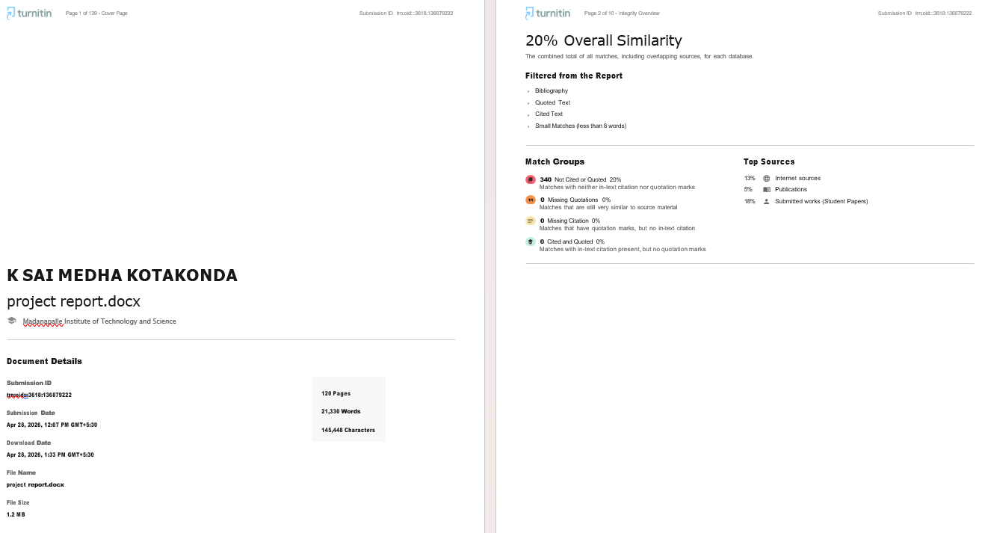

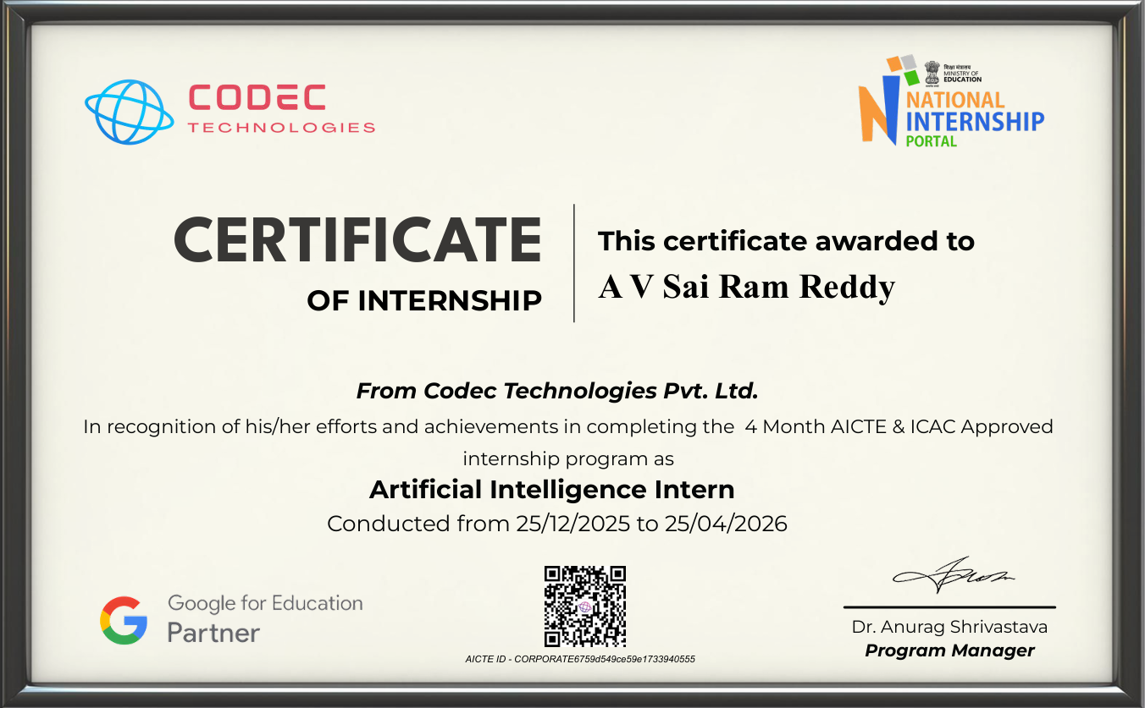



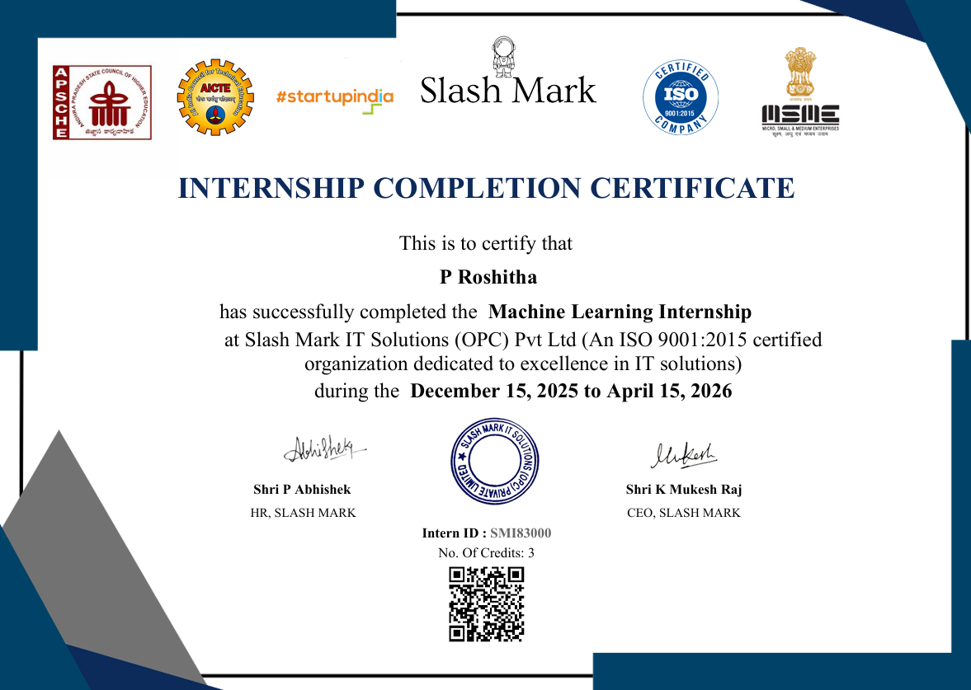

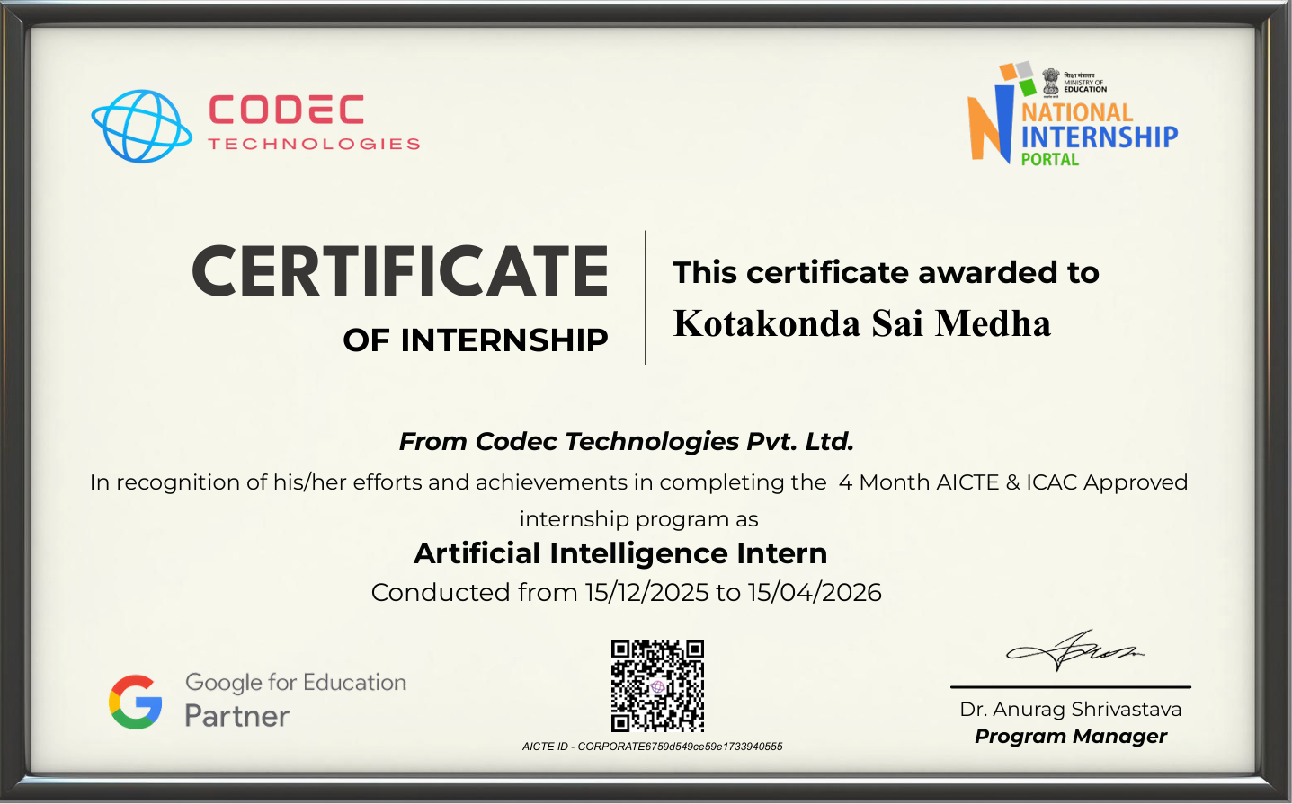

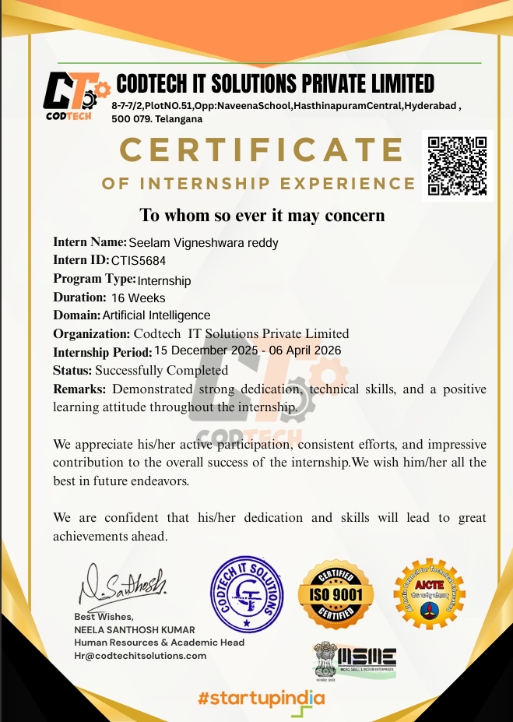

DECLARATION

We hereby declare that the results embodied in this project “EduRAG: A Lightweight RAG Framework for Academic QA” by us under the guidance of Dr. R. Kalpana, Professor & Head, Department of Computer Science and Engineering (Artificial Intelligence) in partial fulfillment of the award of Bachelor of Technology in Computer Science and Engineering (Artificial Intelligence) from Jawaharlal Nehru Technological University Anantapur, Ananthapuramu. The content of this report is not submitted to any other University/Institute for award of any other degree.

Date :
Place : Madanapalle

PROJECT ASSOCIATES:
A V SAI RAM REDDY
C SURAKSHAN
P ROSHITHA
K SAI MEDHA
S VIGNESHWAR

I certify that the above statement made by the students is correct to the best of my knowledge.

Date: Guide

Dr. R . Kalpana

INDEX

S.NO | TOPIC | PAGE NO.
1. | INTRODUCTION
 | 1.1 Introduction | 1
 | 1.2 Motivation | 1
 | 1.3 Problem Definition | 2
 | 1.4 Benefits of EduRAG System | 2
 | 1.5 Role of RAG and LLM in EduRAG | 3
 | 1.6 Objectives of the Project | 3
 | 1.7 System Significance | 4
 | 1.8 Limitations of the Project | 4
 | 1.9 Organization of Documentation | 4
2. | LITERATURE SURVEY
 | 2.1 Introduction | 6
 | 2.2 Existing System | 7
 | 2.3 Disadvantages of Existing System | 13
 | 2.4 Proposed System | 13
 | 2.4.1 Dataset Summary | 14
 | 2.4.2 Proposed Architecture Diagram | 15
 | 2.4.3 Proposed Algorithm | 16
 | 2.5 Advantages of the Proposed System | 17
3. | ANALYSIS
 | 3.1 Introduction | 18
 | 3.2 Software Requirement Specification | 18
 | 3.2.1 Functional Requirements | 19
 | 3.2.2 Non-Functional Requirements | 20
 | 3.2.3 Hardware Requirements | 21
 | 3.2.4 Software Requirements | 21
 | 3.2.5 Package Requirements | 22
4. | DESIGN
 | 4.1 Introduction | 26
 | 4.2 UML Diagrams | 26
 | 4.2.1 State Chart Diagram | 26
 | 4.2.2 Sequence Diagram | 28
 | 4.2.3 Use Case Diagram | 28
 | 4.3 Module Design and Organization | 29
 | 4.4 Summary | 29
5. | IMPLEMENTATION AND RESULTS
 | 5.1 Introduction | 30
 | 5.2 Implementation of Key Functions | 30
 | 5.3 Method of Implementation | 31
 | 5.4 Frontend & Backend Implementation | 55
 | 5.5 Output Screens and Result Analysis | 81
6. | TESTING AND VALIDATION
 | 6.1 Introduction | 84
 | 6.2 Design of Test Cases and Scenarios | 84
 | 6.3 Performance Analysis | 87
 | 6.4 Prediction Outcomes | 88
 | 6.5 Summary | 88
7. | CONCLUSION
 | 7.1 Conclusion | 90
 | 7.2 Future Enhancements | 90
 | REFERENCES | 92

ABSTRACT

Recent advances in large language models have enabled powerful question answering systems. Motivated by recent research trends in RAG, a lightweight Retrieval-Augmented Generation (RAG) system designed for campus-level academic question answering under low-resource constraints. The framework uses structured college data stored in JSON format, which is directly chunked without recursive splitting and embedded using the Sentence-Transformers all-MiniLM-L6-v2 model. Semantic retrieval is performed via a FAISS IndexFlatL2 vector index with top-k nearest-neighbor search. Retrieved text chunks are concatenated to form a grounded context, which is passed to a Flan-T5-XL sequence-to-sequence model for answer generation using a controlled prompt that restricts responses strictly to retrieved content. The system follows a deterministic retrieve-then-generate pipeline, prioritizing factual grounding and minimizing hallucination. EduRAG is fully CPU-compatible, modular, and optimized for small-scale academic deployments such as college information assistants, demonstrating an effective balance between accuracy, simplicity, and computational efficiency.
Keywords: Retrieval-Augmented Generation, Academic Question Answering, Lightweight RAG, Knowledge Retrieval, Hallucination Reduction, Educational Technology.

.

LIST OF FIGURES

Figures | Title | Page No.
2.1 | Proposed Architecture for EduRAG Academic QA System | 15
4.1 | UML Diagram for the project | 27
4.2 | Sequence Diagram | 28
4.3 | Use Case Diagram | 29
5.1 | Output of the colab code | 50
5.2 | Project Root Folder Structure | 56
5.3 | Backend Directory Structure | 56
5.4 | Frontend Directory Structure | 57
5.5 | Backend Requirements File | 57
5.6 | Chat Interface Initial State | 81
5.7 | User Query Submission State | 82
5.8 | Chat Response Display with Sources and Confidence | 82
5.9 | Additional Query Interaction with Assistant Response | 83
6.1 | Evaluation On Cross Validation Dataset | 89

LIST OF TABLES

S.No | Title | Page No.
2.1 | Summary of Existing Works | 9
2.2 | Summary of Dataset | 14
6.1 | Querying without proper dataset | 84
6.2 | Test Case for RAG Pipeline Initialization | 85
6.3 | Test Case for Semantic Retrieval | 85
6.4 | Test Case for LLM Answer Generation | 86
6.5 | Test Case for Rag Pipeline Performance | 86
6.6 | Test Case for Cross-Validation Evaluation | 87

CHAPTER-1

INTRODUCTION

CHAPTER-1

INTRODUCTION

INDRODUCTION
The landscape of academic information retrieval is undergoing a major shift as traditional search methods fail to meet the complex needs of modern campus life. Students and faculty often struggle to find specific institutional information buried in dense documents, while standard AI models frequently provide "hallucinations" confidently stated but incorrect information. To bridge this gap, Retrieval-Augmented Generation (RAG) has emerged as the leading solution, allowing AI to act more like a librarian that looks up facts before it speaks, rather than a poet that relies on imagination.
We need RAG because general AI models are trained on the public internet and don't know the specific, private details of a particular university or college. By implementing a RAG-based framework, an institution can ground the AI’s intelligence in its own verified datasets. This ensures that when a student asks about a specific campus policy or course requirement, the system doesn't just guess; it retrieves the exact relevant document first, ensuring the final answer is rooted in reality and high-quality data.
The current trend in this technology is moving away from massive, expensive server farms and toward "lean" systems that are accessible to institutions with limited technical budgets. By focusing on smart organization and semantic understanding where the computer understands the intent behind a question rather than just matching words colleges can provide high-speed, accurate support tools. This efficiency allows even smaller universities to offer sophisticated digital assistants that understand the nuances of their unique campus environment.
Ultimately, this project represents a shift toward deterministic and reliable academic support. By following a strict "search then answer" workflow, the system eliminates the risks associated with general AI while maintaining a simple and cost-effective footprint. It proves that a powerful academic tool doesn't need to be overly complex to be effective; it simply needs to be precise, well-organized, and focused on delivering factual integrity above all else.

1.2 MOTIVATION
The growing adoption of artificial intelligence in education has increased the need for smart systems that can support students, faculty, and administrators. Academic institutions require tools that can quickly and accurately respond to queries about courses, timetables, regulations, and academic processes. Traditional chatbots, which rely on fixed rule-based logic, lack flexibility and demand significant manual setup. They struggle with complex questions and cannot keep up with constantly changing institutional information.
In contrast, large language models offer strong conversational abilities but often produce answers that are not grounded in official academic data. This can result in misinformation an unacceptable risk in environments where accuracy is essential.
A further limitation is the computational expense of deploying large AI systems. Many institutions, particularly smaller colleges, cannot afford the GPUs or cloud resources required to run such models.
EduRAG addresses these issues by aiming to balance accuracy with efficiency. By integrating retrieval mechanisms with controlled text generation, it ensures responses remain both relevant and trustworthy. Its use of structured JSON data allows direct access to institutional information, eliminating the need for complex databases or heavy preprocessing.
The inclusion of lightweight embedding models and optimized indexing techniques enables the system to run effectively on CPU-based hardware, making it feasible even for resource-limited campuses. Ultimately, the motivation behind EduRAG is to provide a practical, scalable academic question-answering solution that delivers precise information while keeping computational demands low.

PROBLEM DEFINITION
Current academic question-answering systems encounter several limitations that reduce their overall effectiveness. A major issue is the absence of strong grounding in domain-specific knowledge, which often leads to inaccurate or misleading outputs.
Pure LLM-based systems rely heavily on learned language patterns instead of verified institutional data, causing hallucinations an unacceptable drawback in academic contexts where users expect precise and reliable information.
Conventional information-retrieval systems, although accurate, fall short in generating human-like responses. They typically return raw documents or unprocessed data, which lowers usability and diminishes the overall user experience.
Computational demands present another significant challenge. Many modern RAG architectures require high-end hardware and substantial memory resources, making them impractical for institutions with limited infrastructure. Additionally, their preprocessing pipelines often depend on recursive chunking and complex transformations, adding unnecessary overhead and slowing down system deployment.
Ensuring consistent and dependable responses is also difficult when models rely solely on probabilistic generation without proper control mechanisms. To address these concerns, this project introduces a lightweight RAG-based framework that combines efficient retrieval with constraint-driven generation. This design keeps answers factual, contextually accurate, and computationally affordable.
The ultimate objective is to develop a system that performs effectively within academic environments while overcoming the key shortcomings of existing QA solutions.

BENEFITS OF EDURAG SYSTEM
EduRAG offers several advantages that make it highly suitable for academic settings. One of its key strengths is enhanced accuracy, as the system generates answers strictly from retrieved institutional data rather than relying on assumptions. By limiting the generative model to the provided context, EduRAG effectively minimizes hallucinations and ensures that responses remain factual and aligned with actual records.
Another significant benefit is the system’s low computational footprint. Since EduRAG is optimized to run on CPU-based hardware, it becomes accessible to institutions that lack high-end GPUs or advanced infrastructure. The incorporation of FAISS indexing further contributes to efficiency by enabling rapid retrieval of relevant information, even when working with large datasets.
- Improved Response Accuracy: Integration of retrieval ensures chatbot answers are grounded in reliable sources.
- Enhanced Knowledge Coverage: Access to external documents expands the chatbot’s domain expertise beyond training data.
- Reduced Hallucinations: Retrieval minimizes chances of generating incorrect or fabricated information.
- Context-Aware Responses: Dynamic fetching of relevant data allows the chatbot to adapt to user queries effectively.
- Scalable Knowledge Updates: New information can be added to the retrieval index without retraining the model.
- Efficient Query Handling: Combining retrieval with generation speeds up response time for complex questions.
- Personalized Interactions: Retrieved data can be tailored to user context, improving engagement and relevance.
- Academic Reliability: Ensures chatbot outputs are backed by verifiable references, supporting trust in educational use.
1.5 ROLE OF RAG AND LLM IN EDURAG
The EduRAG system integrates retrieval and generation components to achieve effective question answering. The retrieval component is responsible for identifying relevant information from the knowledge base. The system begins by converting structured JSON data into text chunks, which are then embedded using a lightweight transformer model. These embeddings represent the semantic meaning of the data.
FAISS is used to index these embeddings and perform similarity-based searches. When a query is received, it is also converted into an embedding and compared with stored vectors.The top-k most relevant chunks are retrieved based on similarity scores. These chunks form the context for the generation phase.
The generation component uses the Flan-T5-XL model, which is capable of producing coherent and context-aware responses. The model is guided by a controlled prompt to ensure factual accuracy. Prompt engineering plays a crucial role in restricting the model from generating unsupported information. This helps in minimizing hallucination.
The retrieve-then-generate pipeline ensures a clear separation between information retrieval and answer generation, improving system reliability. This integration of RAG and LLM enables EduRAG to deliver accurate, efficient, and user-friendly responses in academic environments.

OBJECTIVES OF THE PROJECT
The primary objective of this project is to develop a lightweight and efficient RAG-based academic question answering system. Another objective is to utilize structured institutional data effectively, ensuring that the system provides accurate and relevant responses. The project aims to implement semantic retrieval using efficient embedding models and FAISS indexing techniques.
Reducing hallucination is a key objective, achieved through controlled prompting and grounded generation. The system is designed to operate on low-resource environments, ensuring compatibility with CPU-based systems. Improving response accuracy and maintaining consistency across queries is another important goal.
The project also focuses on creating a modular and scalable framework that can be extended to other domains. Finally, the objective is to demonstrate that high-quality QA systems can be developed with minimal computational resources.

SYSTEM SIGNIFICANCE
EduRAG represents a significant advancement in the development of lightweight AI systems for education. It demonstrates that effective question answering systems can be built without relying on large-scale infrastructure. The system provides a practical solution for academic institutions that require reliable and efficient information systems. By combining retrieval and generation, EduRAG ensures both accuracy and usability, addressing the limitations of traditional systems.
The framework promotes the use of structured data, making it easier to manage and update academic information.Its low computational requirement makes it accessible to a wide range of institutions, including those with limited technical resources.
The system can be used as a foundation for developing intelligent academic assistants, improving communication and accessibility. EduRAG also contributes to research in RAG systems by showcasing a simplified and efficient implementation. Overall, the system highlights the potential of combining lightweight models with effective retrieval techniques.

LIMITATIONS OF THE PROJECT
Despite its advantages, EduRAG has certain limitations. One limitation is its dependency on the quality and completeness of the input data. The system may struggle with highly complex or ambiguous queries that require deep reasoning beyond retrieved content. Since it uses a lightweight model, its performance may not match that of large-scale GPU-based systems.
The system relies on predefined data and may require updates to handle new academic information. Limited context size can restrict the amount of information used during answer generation. The system may not perform well in domains outside academic data without proper customization. Prompt design plays a critical role, and improper prompts may affect response quality. Future improvements can focus on enhancing model capabilities and expanding system functionality.

ORGANIZATION OF DOCUMENTATION
The project documentation is structured systematically to provide a clear understanding of the system.
Chapter 1: Introduction – Presents the reasoning for the study, defines the problem, outlines the goals, highlights the benefits of RAG Systems, and discusses its limitations.
Chapter 2: Literature Survey – Reviews existing systems, identifies their disadvantages, and explains how EduRAG is built and addresses these gaps with a proposed architecture and algorithm.
Chapter 3: Analysis – Details the functional and non-functional requirements, along with hardware and software specifications necessary for implementing EduRAG.
Chapter 4: Design – Explains the system design using UML diagrams, module organization, and collaborative workflows to illustrate the architecture.
Chapter 5: Implementation and Results – Describes backend and frontend development, provides code snippets, and presents the outcomes of the implemented system.
Chapter 6: Testing and Validation – Covers performance analysis, prediction outcomes, and validation of the system through test cases and evaluation metrics.
Chapter 7: Conclusion – Summarizes the project’s contributions, emphasizes EduRAG’s academic significance, and outlines possible future enhancements.

CHAPTER-2
LITERATURE SURVEY

CHAPTER-2

LITERATURE SURVEY

2.1 INTRODUCTION
The literature survey plays a crucial role in understanding the current advancements and research trends in the field of question answering systems and retrieval-augmented generation. It provides a comprehensive overview of existing methods, technologies, and approaches used to develop intelligent systems capable of processing and responding to natural language queries. By analyzing previous research, it becomes possible to identify gaps, limitations, and opportunities for improvement in the proposed system.
In recent years, the development of Large Language Models (LLMs) has significantly influenced the design of question answering systems. Models such as BERT, GPT, and T5 have demonstrated remarkable capabilities in understanding context and generating meaningful responses. However, these models are limited by their reliance on pre-trained knowledge and often lack real-time data access, which can lead to inaccurate or hallucinated responses.
To address these limitations, researchers have introduced Retrieval-Augmented Generation (RAG) frameworks that combine information retrieval techniques with generative models. This approach ensures that responses are grounded in external knowledge sources, improving accuracy and reliability. Various studies have explored different retrieval methods, embedding techniques, and generation models to enhance the performance of RAG systems.
The literature also highlights the importance of semantic search techniques, particularly the use of embedding models such as Sentence-BERT and MiniLM. These models convert textual data into vector representations, enabling efficient similarity-based retrieval. Combined with vector databases like FAISS, these techniques allow fast and scalable retrieval of relevant information.
Another important aspect discussed in the literature is the role of prompt engineering in controlling the output of generative models. Properly designed prompts can restrict the model to generate responses based only on retrieved context, thereby reducing hallucination and improving factual accuracy.
Despite these advancements, many existing systems are computationally intensive and require high-end hardware resources such as GPUs. This makes them unsuitable for deployment in low-resource environments like small academic institutions. Additionally, complex preprocessing techniques such as recursive chunking increase system complexity and reduce efficiency.
The literature survey also emphasizes the need for domain-specific question answering systems. Academic environments require structured and reliable information systems that can handle queries related to courses, schedules, faculty, and institutional policies. Existing general-purpose systems often fail to meet these specific requirements.
Based on the analysis of existing research, it is evident that there is a need for a lightweight, efficient, and scalable RAG framework tailored for academic applications. The proposed EduRAG system addresses these challenges by integrating structured data, efficient retrieval techniques, and controlled generation in a simplified architecture.

2.2 EXISTING SYSTEM
Recent advancements in Retrieval-Augmented Generation (RAG) have significantly enhanced question answering systems by integrating retrieval mechanisms with generative models, enabling improved factual grounding and reduced hallucination. A comprehensive survey by Zongxi Li et al. (2025) [1] highlights that RAG-based educational systems outperform traditional LLM-based approaches by improving accuracy and enabling dynamic knowledge updates, although challenges such as latency and API costs remain. Lightweight frameworks such as LightRAG (Xiao et al., 2025) [2] and MiniRAG (Fan et al., 2025) [4] focus on simplifying RAG pipelines using graph-based indexing and efficient retrieval strategies, achieving better performance with reduced computational requirements, but introducing preprocessing complexity due to graph construction.
Several studies emphasize optimizing retrieval strategies to enhance system efficiency and accuracy. RAP-RAG (Ji et al., 2025) [5] introduces adaptive retrieval planning, dynamically selecting retrieval strategies based on query complexity, resulting in improved accuracy while maintaining efficiency. MAIN-RAG (Chang et al., 2025) [6] adopts a multi-agent retrieval approach, where multiple retrievers generate candidate contexts, significantly improving answer relevance but increasing computational cost. FAIR-RAG (Aghajani Asl et al., 2025) [7] further improves retrieval through iterative refinement, enabling systems to gather missing evidence via repeated querying, though at the cost of increased inference latency.
Research has also explored improving retrieval precision and representation. SAGE (Zhang et al., 2025) [8] introduces semantic segmentation for better chunking and context selection, reducing retrieval noise and improving efficiency. OpenRAG (Zhou & Chen, 2025) [9] proposes end-to-end retriever optimization tailored for in-context learning, enhancing overall QA accuracy. HeteRAG (Yang et al., 2025) [10] separates knowledge representations for retrieval and generation, improving both efficiency and performance, albeit with increased system complexity. VersionRAG (Huwiler et al., 2025) [11] addresses evolving document scenarios using version-aware retrieval, achieving high accuracy in version-sensitive tasks but remaining domain-specific.
Modular and composable architectures have emerged as another important direction. ComposeRAG (Wu et al., 2025) [12] decomposes the RAG pipeline into modular components, improving multi-hop reasoning and reducing ungrounded responses, though increasing architectural complexity. CG-RAG (Hu et al., 2025) [13] integrates citation graph retrieval to enhance research-based QA, improving both retrieval accuracy and generation quality while requiring complex graph construction. Survey-based works such as Cheng et al. (2025) [14] and Sharma (2025) [15] provide comprehensive taxonomies of RAG systems, identifying trends toward knowledge-oriented retrieval, hybrid architectures, and domain-specific optimization.
Domain-specific implementations further demonstrate the effectiveness of RAG systems. The hybrid RAG model proposed by Yueqing Xi et al. (2025) [2] combines retrieval with multi-model answer validation to improve reliability and reduce hallucination, particularly in legal QA scenarios. Similarly, Gamaiunova and Sidorov (2025) [3] developed a lightweight RAG system for ERP technical support, achieving significant improvements in accuracy and response quality through fine-tuning and efficient retrieval, though requiring domain-specific datasets and expert validation.
Despite these advancements, several limitations persist. Many RAG systems rely on complex pipelines involving graph-based indexing, multi-agent retrieval, or iterative refinement, increasing computational overhead and limiting deployment in low-resource environments. Additionally, while hallucination is reduced, it is not completely eliminated, especially when retrieval quality is insufficient. Most high-performance systems also depend on large-scale datasets and GPU-intensive infrastructure, making them less suitable for small-scale academic applications.
Based on the analysis of these [1-15] research works, there is a clear need for a lightweight, efficient, and domain-specific RAG framework that balances accuracy, simplicity, and computational efficiency. EduRAG addresses these gaps by integrating structured JSON-based academic data, efficient MiniLM embeddings, FAISS-based semantic retrieval, and controlled Flan-T5 generation within a deterministic retrieve-then-generate pipeline. Unlike complex graph-based or multi-agent systems, EduRAG minimizes system overhead while maintaining strong factual grounding, making it suitable for CPU-based deployment in academic environments and practical for real-world educational question answering systems.

Table 2.1 Summary of Existing Research Works
S.No | Author Name, year of publication | Title | Methodology | Algorithms used | Dataset Name (if any) | Result | Limitation
1. | Zongxi Li et al., 2025 [1] | Retrieval-Augmented Generation for Educational Application: A Systematic Survey | Systematic literature review of RAG-based educational systems; analysis of indexing, retrieval, and generation pipelines | BM25, Dense Passage Retrieval (DPR) | Web of Science, Google Scholar | Shows RAG significantly reduces hallucination, improves factual accuracy, supports dynamic knowledge updates | High cost and latency due to LLM APIs, limited multimodal support
2. | Xiao et al., Yueqing Xi 2025 [2] | LightRAG: Simple and Fast Retrieval-Augmented Generation | Graph-based RAG framework with dual-level retrieval and dynamic knowledge graph construction from text. | LM-based entity extraction, graph construction, low-level and high-level retrieval | Agriculture, Computer Science, Legal | Improves answer accuracy, diversity, and comprehension | Graph construction adds complexity; performance depends on quality
3. | Gamaiunova & Sidorov, 2025 [3] | Lightweight Retrieval-Augmented Generation System for Technical Support in Domain-Specific ERP Platforms | Build a lightweight RAG system for ERP technical support, LoRA fine-tuning, vector retrieval, and feedback loop | DeepSeek-7B, LoRA, INT8 Quantization, Sentence-BERT | 1000 domain-specific ERP Q&A pairs, 200 test queries | EM = 86% (vs 72% without RAG), BLEU-2 = 0.78, Perplexity reduced from 36.1 to 5.2; 93% correct in expert review. | Requires domain-specific data collection and expert feedback; performance depends on quality of fine-tuning
4. | Tianyu Fan et al., 2025 [4] | MiniRAG: Towards Extremely Simple Retrieval-Augmented Generation | Design of a lightweight RAG using heterogeneous graph indexing (chunks + entities) and topology-based retrieval | Entity extraction, Heterogeneous Graph Indexing, Graph-based Retrieval, Cosine Similarity | LiHuaWorld, MultiHop Short | 1.3-2.5x better than lightweight baselines with less storage; robust SLMs (Phi-3.5, Qwen-3B). | Graph construction adds preprocessing cost; designed mainly for on-device and short-document scenarios

S.No | Author Name, year of publication | Title | Methodology | Algorithms used | Dataset Name  (if any) | Result | Limitation
5. | Xu Ji et al., 2025 [5] | RAP-RAG: A Retrieval-Augmented Generation Framework with Adaptive Retrieval Task Planning | Light-weight RAG using heterogeneous weighted graph indexing and an adaptive planner that selects retrieval strategy based on query complexity | Vector Retrieval, Local Retrieval, Dual Retrieval, Topology-Enhanced Retrieval, Graph Indexing | LiHua-World, MultiHop-RAG, Hybrid-SQuAD | Achieves 3-5% higher accuracy than MiniRAG, maintains efficiency with ~15% lower storage | Adaptive planner adds slight latency, evaluated mainly on English datasets
6. | Chia-Yuan Chang et al., 2025 [6] | MAIN-RAG: Multi-Agent Filtering Retrieval-Augmented Generation | Multi-agent RAG framework where multiple specialized retrievers generate candidate contexts | Multi-Agent Retrieval, FAISS, Filtering Module, Cosine Similarity | HotpotQA, Natural Questions, WikiQA | Improves answer relevance and factual correctness over standard RAG | Higher computational cost due to multiple retrievers and filter agents
7. | Mohammad Aghajani Asl et al., 2025 [7] | FAIR-RAG: Faithful Adaptive Iterative Refinement for Retrieval-Augmented Generation | Introduces an iterative refinement cycle that detects information gaps and dynamically issues sub-queries | Structured Evidence Assessment, Adaptive Query Refinement, Iterative RAG | HotpotQA, 2WikiMultiHopQA, MusiQue | Significant F1 improvement over iterative baselines; more complete context | Increased inference latency due to iterative refinement
8. | Jintao Zhang et al., 2025 [8] | SAGE: A Framework of Precise Retrieval for RAG | Semantic segmentation of corpus into semantically complete chunks and dynamic selection of context using relevance decay analysis | Semantic Segmentation Model, Dynamic Chunk Selection | Custom QA corpora (semantic segments) & benchmark tasks | Improves QA accuracy and reduces retrieval noise; reduces token cost in inference. | Requires pretrained segmentation model and extra retrieval overhead

S.No | Author Name, year of publication | Title | Methodology | Algorithms used | Dataset Name (if any) | Result | Limitation
9. | Jiawei Zhou & Lei Chen, 2025 [9] | OpenRAG: Optimizing RAG End-to-End via In-Context Retrieval Learning | End-to-end training of the retriever tuned for in-context relevance rather than generic IR relevance | End-to-end Retriever Optimization, In-Context Learning | Standard QA and RAG benchmarks | ~4% consistent QA accuracy improvement; small retriever models outperform larger | Requires retriever fine-tuning with specific RAG tasks
10. | Peiru Yang et al., 2025 [10] | HeteRAG: A Heterogeneous RAG Framework with Decoupled Knowledge Representations | Decouples knowledge representation for retrieval vs generation; uses short chunks for generation | Dual Representation Embedding, Adaptive Prompt Tuning | QA benchmarks & document corpora | Improves both retrieval accuracy and generation efficiency | Complexity in managing dual representations and tuning prompt strategies
11. | Daniel Huwiler, Kurt Stockinger & Jonathan Furst, 2025 [11] | VersionRAG: Version-Aware Retrieval-Augmented Generation for Evolving Documents | Version-aware RAG that models document evolution via a hierarchical graph to handle changing technical documentation. | Version graphs, Hierarchical Retrieval, Intent Classification, Vector Filtering | VersionQA (100 manually curated versioned document QA pairs) | Achieved 90% accuracy vs naive RAG's ~58-64% on version-sensitive questions. | Specialized to versioned technical documentation; may be less effective on generic QA tasks.
12. | Ruofan Wu et al., 2025 [12] | ComposeRAG: A Modular and Composable RAG for Corpus-Grounded Multi-Hop Question Answering | Modular RAG design that decomposes the pipeline into discrete components | Modular pipeline architecture, Self-reflection refinement | Multiple multi-hop QA benchmarks | Up to 15% improvement in accuracy and significant reduction in ungrounded answers. | Increased architectural complexity vs monolithic RAG.

S.No | Author Name, year of publication | Title | Methodology | Algorithms used | Dataset Name (if any) | Result | Limitation
13. | Yuntong Hu et al., 2025 [13] | CG-RAG: Research Question Answering by Citation Graph Retrieval-Augmented LLMs | Integrates citation graph retrieval with dense/sparse signals for better research QA retrieval. | Citation graph encoding, Lexical-Semantic Graph Retrieval (LeSeGR) | Research QA benchmarks across multiple domains | Outperformed state-of-the-art RAG methods in retrieval accuracy and generation quality | Requires construction and maintenance of citation graphs
14. | Mingyue Cheng et al., 2025 [14] | A Survey on Knowledge-Oriented Retrieval-Augmented Generation | Comprehensive survey of RAG architectures, retrieval mechanisms, generation strategies | Survey categorizes many retrieval & generation algorithms | Various RAG benchmarks discussed | Provides taxonomy of RAG, identifies trend toward knowledge-oriented designs | Survey, not a novel method or empirical system.
15. | C. Sharma et al., 2025 [15] | Retrieval-Augmented Generation: Taxonomy and Perspectives | Systematic synthesis of recent RAG research, categorizing retriever-centric approaches | Analytical taxonomy covering DPR, dense/sparse retrievers | Discusses evaluation frameworks and QA benchmarks | Identifies key research trends and challenges, and highlights performance | High-level synthesis; not an empirical performance paper

2.3 DISADVANTAGES OF THE EXISTING SYSTEM
The existing works from [1–15] reveal that current Retrieval-Augmented Generation (RAG) and academic QA systems face several challenges that limit their efficiency and practical usability. One of the major issues is the high computational cost, as most RAG-based systems rely on large-scale transformer models such as GPT, T5, and RETRO. These models require significant memory, GPU resources, and inference time, making them unsuitable for lightweight or real-time academic applications.
Another key limitation is the latency in retrieval and generation. Since traditional RAG systems involve retrieving multiple documents and then generating responses, the process becomes time-consuming. This delay affects user experience, especially in academic environments where quick responses are required.
Existing systems also suffer from hallucination problems, where the model generates incorrect or unsupported answers despite retrieval. This reduces reliability, particularly in academic settings where factual correctness is critical. Additionally, many systems lack proper grounding mechanisms to ensure that generated answers strictly follow retrieved content.
Another drawback is the lack of domain-specific optimization. Most RAG models are trained on general-purpose datasets and are not specifically tailored for academic question answering. This results in irrelevant or overly generic responses when handling subject-specific queries.
Furthermore, these systems require large-scale datasets and complex indexing mechanisms such as FAISS or dense retrieval embeddings. Maintaining and updating such indexes increases system complexity and resource consumption. Limited dataset quality and poor document structuring further reduce retrieval effectiveness.
Another major issue is poor efficiency in low-resource environments. Existing models are not optimized for deployment on systems with limited hardware capabilities, such as student laptops or institutional servers with restricted resources.
To overcome these challenges, there is a need for a lightweight, efficient, and domain-specific RAG framework that reduces computational overhead, improves retrieval relevance, minimizes hallucination, and ensures faster response generation for academic QA tasks.

PROPOSED SYSTEM
The proposed system, EduRAG, introduces a lightweight Retrieval-Augmented Generation framework specifically designed for academic question answering. The system aims to provide accurate, fast, and resource-efficient responses by optimizing both retrieval and generation components.
Unlike traditional RAG systems, EduRAG uses:
- Lightweight embedding models for efficient retrieval
- Optimized document indexing for faster search
- Compact language models for answer generation
The system follows a structured pipeline:
- Query input
- Lightweight document retrieval
- Context filtering and ranking
- Answer generation
- Response output
This approach reduces latency and computational cost while maintaining high relevance and accuracy.
Additionally, EduRAG focuses on academic domain adaptation, ensuring that responses are:
- Contextually relevant
- Factually accurate
- Aligned with academic content
The system also minimizes hallucination by grounding responses strictly in retrieved documents.
2.4.1 DATASET SUMMARY
The dataset used for EduRAG consists of academic documents, textbooks, research papers, lecture notes, and question-answer pairs. The dataset is designed to support domain-specific academic queries across subjects such as Computer Science, Mathematics, and Engineering. Sample documents include structured and unstructured academic content, as shown in Fig 2.1. The dataset includes both text corpus and metadata to improve retrieval and contextual understanding.
Dataset Source: Open Academic Datasets, Research Paper Repositories, and Educational Content Libraries
Table 2.2 Summary of Dataset
Category | No. of Entries | Description
College Info | 10 | General information about MITS including history, location, rankings, vision, collaborations
UG Programs | 13 | Undergraduate courses including CSE, AI/ML, Cyber Security, ECE, EEE, Mechanical, Civil, etc.
PG Programs | 8 | Postgraduate programs such as M.Tech specializations, MBA, MCA
PhD Programs | 8 | PhD disciplines, eligibility, selection process, and important dates
Admissions | 8 | Admission process, entrance exam (MITSUCET), steps, and contact details
Academic Schools | 1 | Structure of academic divisions (Engineering, Computing, Management)
Placements | 4 | Placement support, recruiters, and alumni testimonials
Facilities | 4 | Campus infrastructure, hostels, labs, and student environment
Events | 3 | Technical fest, FDP, and academic events
Accreditations & Rankings | 4 | NAAC, NBA, NIRF ranking, approvals
Contact | 5 | Address, phone, email, website, and social media

Table 2.2 displays a structured summary of a dataset for a college-related project, categorized into eleven distinct sections. It details information ranging from College Info and Academic Programs (UG, PG, and PhD) to administrative aspects like Admissions and Placements. The table also quantifies the data by listing the number of entries for each category, such as 13 for UG Programs and 10 for general College Info. Each entry includes a concise description of the specific content covered, providing a clear overview of the institutional data architecture.

2.4.2 PROPOSED ARCHITECTURE DIAGRAM
The proposed EduRAG framework focuses on developing a lightweight, efficient, and domain-specific Retrieval-Augmented Generation (RAG) system for academic question answering. The system integrates document retrieval and answer generation modules to provide accurate, context-aware responses to user queries while maintaining low computational cost.
The dataset consists of academic documents, research papers, lecture notes, and QA pairs, along with structured metadata such as subject, topic, keywords, and difficulty level. The textual data undergoes preprocessing steps including tokenization, stop-word removal, and normalization to ensure consistency and improve retrieval quality. Metadata is also refined through encoding and filtering to enhance contextual understanding.
For efficient retrieval, the system uses lightweight embedding models (e.g., MiniLM / Sentence Transformers) to convert documents into vector representations. These embeddings are indexed using efficient similarity search techniques such as FAISS or cosine similarity, enabling fast and accurate retrieval of relevant academic content.

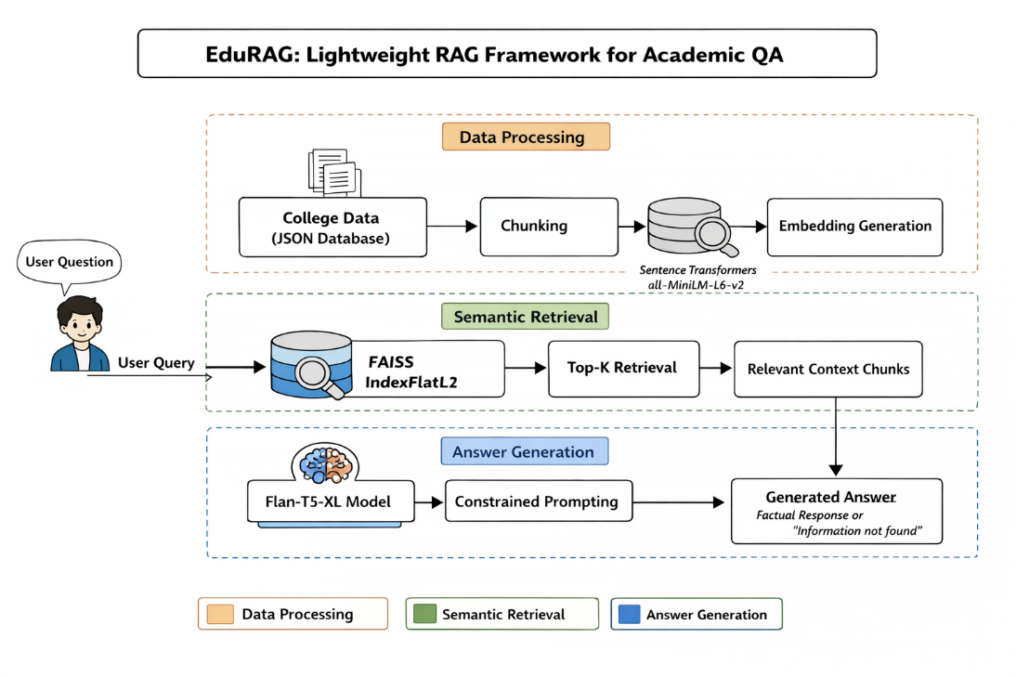
Fig 2.1 Proposed Architecture for EduRAG Academic QA System
Fig 2.1 illustrates a comprehensive system divided into three functional layers: data processing, semantic retrieval, and answer generation. In the initial stage, college information from a JSON database is partitioned into smaller segments and converted into vector embeddings using the Sentence Transformers model. These embeddings are managed within a FAISS index to enable efficient similarity searching when a user submits a query.
During the retrieval phase, the system identifies the most relevant context chunks through a top-k selection process. These snippets are then passed to a Flan-T5-XL model, which utilizes constrained prompting to produce a focused response. This design ensures that the final output is either a factually grounded answer based on the retrieved academic data or a clear notification if the information is unavailable.
The retrieved documents are passed to a lightweight language model (LLM) for answer generation. Instead of using large and resource-intensive models, EduRAG employs optimized models to reduce latency while maintaining answer quality. The system also includes context filtering and ranking mechanisms to ensure that only the most relevant information is used for answer generation.
The training pipeline includes:
- Document embedding generation
- Index building
- Query encoding
- Retrieval ranking
The dataset is split into training, validation, and test sets to evaluate performance and ensure generalization.
During inference, the system processes user queries by retrieving relevant documents and generating answers grounded in retrieved content. This reduces hallucination and improves factual correctness. Overall, the EduRAG architecture provides:
- Fast response time
- Low computational cost
- High relevance for academic queries
- Reduced hallucination through retrieval grounding
This streamlined pipeline aligns with the objective of building an efficient academic QA system, suitable for students, researchers, and educational platforms.

2.4.3 PROPOSED ALGORITHM
Step 1: Start
Step 2: Load Academic Dataset
- Documents, research papers, QA pairs
Step 3: Load Metadata (.csv file)
- Subject, topic, keywords, difficulty level
Step 4: Merge document dataset with metadata

Step 5: Data Preprocessing
Step 5.1: Tokenization of text
Step 5.2: Remove stop words and noise
Step 5.3: Normalize text (lowercasing, stemming/lemmatization)
Step 5.4: Encode metadata features

Step 6: Embedding Generation
Step 6.1: Convert documents into vector embeddings
Step 6.2: Use lightweight models (MiniLM / Sentence Transformers)
Step 6.3: Store embeddings in vector database

Step 7: Indexing & Retrieval Setup
Step 7.1: Build vector index (FAISS / cosine similarity)
Step 7.2: Enable fast nearest-neighbor search
Step 7.3: Optimize retrieval ranking

Step 8: Model Development
Step 8.1: Encode user query into embedding
Step 8.2: Retrieve top-k relevant documents
Step 8.3: Apply ranking and filtering
Step 8.4: Pass retrieved context to lightweight LLM

Step 9: Answer Generation
Step 9.1: Generate answer using retrieved context
Step 9.2: Ensure answer is grounded in documents
Step 9.3: Reduce hallucination

Step 10: Model Prediction
Step 10.1: Input user query
Step 10.2: Retrieve relevant academic content
Step 10.3: Generate final answer
Step 10.4: Display answer with source context

Step 11: Performance Monitoring
Step 11.1: Evaluate using accuracy and relevance score
Step 11.2: Monitor response latency
Step 11.3: Optimize retrieval and generation
Step 11.4: Update index with new documents
Step 12: Stop

2.5 ADVANTAGES OF THE PROPOSED SYSTEM
The proposed EduRAG system offers several advantages:
- Lightweight architecture reduces computational cost
- Faster response time compared to traditional RAG systems
- Efficient retrieval using optimized embeddings
- Reduced hallucination through retrieval grounding
- Domain-specific academic QA improves relevance
- Scalable system for adding new academic content
- Lower memory usage compared to large LLMs
- Real-time query processing capability
- Improved accuracy through context-aware answers
- Flexible architecture for integrating new models
- Supports educational platforms and research tools

CHAPTER-3

ANALYSIS

CHAPTER-3 ANALYSIS

3.1 INTRODUCTION
EduRAG is a lightweight Retrieval-Augmented Generation (RAG) framework designed specifically to address the challenges of academic question answering. In modern educational environments, students and researchers require quick, accurate, and context-aware answers from vast collections of academic resources such as textbooks, research papers, and lecture notes. Traditional search systems often fail to provide precise answers, while large language models may generate responses that are not grounded in reliable sources. EduRAG bridges this gap by combining efficient retrieval with controlled text generation.
The primary objective of EduRAG is to deliver high-quality academic answers with reduced computational overhead. Unlike conventional RAG systems that rely on large-scale transformer models and heavy retrieval mechanisms, EduRAG focuses on lightweight components. This ensures that the system can operate efficiently even on moderate hardware setups, making it suitable for educational institutions and individual learners.
One of the key strengths of EduRAG lies in its ability to retrieve relevant academic content before generating answers. This retrieval-first approach ensures that the generated responses are based on factual information rather than model hallucination. By grounding the answers in retrieved documents, the system improves both reliability and interpretability.
The system also addresses the challenge of latency in question answering systems. Traditional RAG models often experience delays due to complex retrieval pipelines and large generative models. EduRAG optimizes both retrieval and generation stages, enabling faster response times without significantly compromising accuracy.
However, the system has certain limitations. Its performance depends heavily on the quality and structure of the academic dataset. Poorly organized or incomplete documents may affect retrieval accuracy. Additionally, while the model is lightweight, embedding generation and indexing still require computational resources.
Despite these challenges, EduRAG provides a balanced solution that enhances accuracy, efficiency, and scalability. It is particularly useful for applications such as e-learning platforms, academic assistants, and research support tools, where quick and reliable information retrieval is essential.

3.2 SOFTWARE REQUIREMENT SPECIFICATION
The Software Requirements Specification for EduRAG: A Lightweight RAG Framework for Academic QA defines the essential tools, frameworks, and technologies required to efficiently build, deploy, and maintain the system. Since EduRAG focuses on delivering accurate academic question answering through a lightweight Retrieval-Augmented Generation (RAG) approach, the system emphasizes efficiency, scalability, and reduced computational overhead.
EduRAG is designed within a Python-based ecosystem, which offers extensive support for natural language processing, machine learning, and rapid prototyping. Frameworks such as TensorFlow and PyTorch are utilized for model handling, while Hugging Face Transformers provides pre-trained transformer models suitable for academic text understanding and response generation.
To enable efficient document retrieval, EduRAG incorporates vector search mechanisms using FAISS. This allows fast indexing and similarity-based retrieval of academic documents, ensuring relevant context is supplied to the generative model. The use of vector databases is optimized to support lightweight storage and quick query responses.
The system also integrates robust preprocessing modules to handle large-scale academic datasets. Key steps such as text cleaning, tokenization, normalization, and stop-word removal ensure that the input data is structured and consistent. These preprocessing techniques play a critical role in improving embedding quality and retrieval accuracy.
A defining feature of EduRAG is its reliance on lightweight embedding models. Instead of computationally expensive large-scale transformers, the system uses efficient alternatives such as MiniLM and Sentence Transformers. These models provide a strong balance between semantic understanding and computational efficiency, making the framework suitable for resource-constrained environments.
The software environment is designed with scalability and flexibility in mind. EduRAG supports incremental updates, allowing new academic content to be indexed without requiring full system retraining. This ensures continuous learning and adaptability as the knowledge base grows.
Overall, the software requirements ensure that EduRAG remains lightweight, efficient, and scalable, while delivering high-quality academic question answering through an optimized integration of retrieval and generation components.

3.2.1 FUNCTIONAL REQUIREMENTS
The functional requirements of EduRAG define the core operations that the system must perform to deliver effective academic question answering. These functions are organized into multiple modules, each responsible for a specific task in the RAG pipeline.
The first requirement is data collection, where academic documents such as textbooks, research papers, and lecture notes are gathered. These documents form the knowledge base of the system. The quality and diversity of this dataset directly influence the system’s performance.
Next is data integration, where the collected documents are organized along with metadata such as subject, topic, and keywords. This structured organization helps improve retrieval efficiency and ensures that relevant documents are identified quickly.
The system then performs data preprocessing, which includes text cleaning, tokenization, stop-word removal, and normalization. These steps ensure that the text data is consistent and suitable for embedding generation. Proper preprocessing enhances both retrieval accuracy and model performance.
Another critical function is embedding generation, where documents are converted into vector representations. These embeddings capture semantic meaning and enable similarity-based retrieval. Lightweight embedding models are used to ensure efficiency.
The retrieval module is responsible for identifying the most relevant documents based on the user query. It uses similarity search techniques to retrieve top-k documents from the vector database. This step ensures that only relevant context is passed to the generation model.
Finally, the answer generation module uses a lightweight language model to generate responses based on retrieved content. The system ensures that the generated answers are grounded in the retrieved documents, reducing hallucination and improving reliability.

3.2.2 NON-FUNCTIONAL REQUIREMENTS

The system is designed to operate as a lightweight, CPU-optimized Retrieval-Augmented Generation (RAG) solution, which necessitates strict performance efficiency under limited computational resources. The response generation time must remain low to ensure a smooth conversational experience, particularly because the pipeline includes multiple stages such as text chunking, embedding generation, vector search, and LLM-based answer synthesis. As observed in the execution and evaluation sections of the notebook, the system processes queries through a structured pipeline with measurable latency, making it essential to maintain optimized inference times and minimal overhead across all components.

The architecture should ensure that query responses are generated within a few seconds even on standard hardware without GPU acceleration.

Scalability is an important consideration, as the system should support an increasing volume of institutional data and user queries without degradation in performance. The modular pipeline design, which separates data preparation, embedding, retrieval, and generation stages, enables horizontal and vertical scalability. The vector store must efficiently handle growing embeddings, while the retrieval mechanism should maintain consistent accuracy regardless of dataset size. The system should also allow seamless integration of additional datasets such as new departments, courses, or institutional updates without requiring significant restructuring.

Reliability and availability are critical to ensure uninterrupted access to campus-related information. The system must consistently return relevant answers even when queries are ambiguous or partially outside the dataset scope. As indicated in the prompt design within the LLM generator, fallback behavior is incorporated to handle unknown queries gracefully by restricting responses to available context . The system should maintain high uptime and ensure fault tolerance, particularly in handling failures during embedding loading, model initialization, or vector search operations.

Usability plays a significant role in the effectiveness of the chatbot, requiring a simple and intuitive interaction interface. The conversational loop implemented in the main execution ensures continuous user interaction, allowing users to ask multiple queries in a natural language format. The system must provide clear, concise, and contextually accurate responses without requiring technical knowledge from the user. Additionally, responses should be structured in a human-readable format, avoiding overly complex or verbose outputs.

Maintainability is ensured through a clean modular code structure, where each component such as data management, chunking, vector storage, and generation is encapsulated within separate classes. This modularity allows developers to update or replace individual components, such as switching embedding models or LLM providers, without affecting the overall system. The use of open-source libraries and standard frameworks further enhances maintainability and reduces dependency risks.

Security and data integrity must be preserved, particularly when handling institutional information. Although the dataset primarily contains public academic data, the system should prevent unauthorized modification of stored data and ensure that the retrieval mechanism does not expose unintended or sensitive information. Input validation should be implemented to prevent malformed queries from affecting system stability, and logging mechanisms should track system activity for monitoring and debugging purposes.

Accuracy and relevance of responses are essential non-functional aspects, especially in an educational context. The evaluation section demonstrates the use of semantic similarity and correctness metrics to assess system performance, highlighting the need for consistent answer quality . The system should maintain high retrieval precision and ensure that generated responses are grounded strictly in retrieved context, minimizing hallucinations and misinformation.

3.2.3 HARDWARE REQUIREMENTS
The implementation of the EduRAG framework requires a moderately powerful hardware setup to efficiently handle tasks such as document embedding, vector retrieval, and answer generation. Since the system is designed to be lightweight compared to traditional RAG models, it can operate on standard academic or institutional systems without requiring extremely high-end infrastructure.
The system processes large volumes of academic text data, including research papers and documents, and performs embedding generation and similarity search. These operations require sufficient computational power and memory to ensure smooth performance and low latency.
A capable GPU is recommended to accelerate embedding generation and improve the efficiency of model inference. However, since EduRAG uses lightweight models, it can still function on CPU-based systems with slightly reduced performance.
Storage plays a critical role in maintaining document corpora, embeddings, and indexing structures. SSD storage ensures faster read/write operations, which is essential for real-time retrieval.
Reliable input and output devices enable user interaction with the system, allowing queries to be entered and results to be displayed efficiently.

Hardware Specifications
System | : | Intel i5 or above
RAM | : | 32 GB or above
GPU | : | NVIDIA RTX 3060 / RTX 3080
Hard Disk | : | 1 TB SSD
Input Device | : | Keyboard and Mouse
Output Device | : | Monitor

3.2.4 SOFTWARE REQUIREMENTS
The EduRAG system is built using a flexible and scalable software environment that supports natural language processing, vector retrieval, and lightweight generative models. The software stack is designed to ensure efficient development, testing, and deployment of the academic QA system.
The system operates on modern operating systems such as Windows or Linux, providing compatibility with widely used development tools. Python is used as the primary programming language due to its rich ecosystem of machine learning and NLP libraries.
Development platforms such as Jupyter Notebook enable rapid prototyping and experimentation, while web browsers like Google Chrome are used for accessing deployed applications and interfaces.
The software environment also supports integration with libraries for embedding generation, indexing, and retrieval, ensuring smooth execution of the EduRAG pipeline.

Software Specifications
Operating System | : | Windows 10/11 (64-bit)
Back End | : | Python 3.10 or above
Development Platform | : | Jupyter Notebook, Google Chrome

3.2.5 PACKAGE REQUIREMENTS
TensorFlow
TensorFlow is an open-source machine learning framework that can be utilized in EduRAG for handling computationally intensive operations such as embedding generation and vector transformations. It provides efficient tensor operations and supports both CPU and GPU execution, making it suitable for scalable academic data processing. In this project, TensorFlow can assist in optimizing numerical workflows involved in semantic search and representation learning.
Keras.models
The keras.models module provides a simplified interface for constructing and managing neural network architectures. Within EduRAG, it can be leveraged for designing lightweight models for text representation and embedding tasks.
• Sequential Model – Suitable for linear stacking of layers in simple NLP pipelines
• Functional API – Enables flexible architectures with multiple inputs or outputs
It also supports model persistence, allowing trained components to be saved and reused during deployment.
Keras.layers
The keras.layers module offers essential building blocks required for neural network construction. In EduRAG, these layers can be used for preprocessing or embedding-related pipelines.
• Dense Layer – Used for fully connected transformations
• Dropout Layer – Helps prevent overfitting
• Flatten Layer – Converts structured data into vector format
• BatchNormalization – Stabilizes and accelerates training
These layers contribute to efficient feature extraction and representation.
Sentence-Transformers
Sentence-Transformers is a key library used in EduRAG for generating high-quality semantic embeddings from textual data. It enables conversion of user queries and documents into dense vector representations, which are essential for similarity-based retrieval. The library is optimized for sentence-level understanding and integrates seamlessly with vector databases, making it highly effective for RAG-based systems.
FAISS (Facebook AI Similarity Search)
FAISS is used for efficient similarity search and vector indexing. In EduRAG, it plays a central role in retrieving the most relevant document chunks based on semantic similarity.
• Fast nearest neighbor search
• Scalable indexing for large datasets
• Supports L2 and cosine similarity
It ensures low-latency retrieval even as the dataset grows.
Transformers (Hugging Face)
The Transformers library is used for loading and utilizing pre-trained language models for response generation. In EduRAG, it powers the LLM component responsible for generating answers based on retrieved context.
• Supports state-of-the-art NLP models
• Enables text generation and understanding
• Provides tokenizer and model utilities
This library enables high-quality, context-aware responses.
PyTorch
PyTorch is used as the backend framework for running transformer models and embedding computations. It provides dynamic computation graphs and efficient tensor operations, making it suitable for research-oriented and production-ready NLP systems. In EduRAG, it supports model inference and embedding generation workflows.
Scikit-learn
Scikit-learn is used for evaluation and auxiliary machine learning tasks within the project. It contributes to:
• Similarity computations
• Performance evaluation metrics
• Data preprocessing techniques
• Basic clustering or ranking logic
It enhances the analytical capabilities of the system.
NumPy
NumPy is fundamental for numerical operations and vector manipulation in EduRAG. It is used for:
• Handling embedding vectors
• Performing matrix operations
• Supporting efficient numerical computations
Its performance optimization is crucial for real-time retrieval systems.
Pandas
Pandas is used for managing structured datasets and metadata in the project.
• Data cleaning and preprocessing
• Handling JSON and tabular datasets
• Organizing academic information
It simplifies data handling and improves pipeline efficiency.
JSON
The json module is used for storing and loading structured dataset information. In EduRAG, it plays a key role in maintaining the knowledge base, including categories such as admissions, programs, facilities, and placements. It ensures easy data interchange and readability.
os
The os module is used for system-level operations such as file handling and directory management.
• Managing dataset files
• Handling file paths
• Supporting cross-platform compatibility
It ensures smooth interaction with the file system.
Time
The time module is used for measuring execution performance and latency. In EduRAG, it helps track response times during evaluation and benchmarking, ensuring the system meets performance requirements.
LangChain
LangChain is a powerful framework used in EduRAG to orchestrate the Retrieval-Augmented Generation (RAG) pipeline. It connects different components such as embeddings, vector stores, and language models into a cohesive workflow.
• Enables chaining of LLM calls with retrieval logic
• Supports prompt templates and memory handling
• Simplifies integration with vector databases like FAISS
It plays a central role in structuring the end-to-end query-to-response pipeline.
FastAPI
FastAPI is used to build high-performance backend APIs for EduRAG. It allows efficient handling of user queries and communication between frontend and model services.
• Asynchronous request handling for speed
• Automatic API documentation (Swagger UI)
• Easy integration with ML models
It ensures scalable and production-ready deployment of the system.
Uvicorn
Uvicorn is an ASGI server used to run FastAPI applications. It provides lightweight and fast execution of backend services.
• High-speed asynchronous server
• Supports real-time API interactions
• Optimized for modern Python web frameworks
It enables smooth serving of EduRAG APIs.
LangChain Community Extensions
This module provides additional integrations and tools that extend LangChain’s capabilities. In EduRAG, it helps connect external services such as vector stores and document loaders.
• Supports multiple data sources
• Enhances modular pipeline design
• Provides plug-and-play integrations
It improves flexibility in building scalable RAG systems.
Hugging Face Embeddings
Hugging Face embedding models are used to convert text into dense vector representations. In EduRAG, they enable semantic understanding of queries and documents.
• Pretrained transformer-based embeddings
• High semantic accuracy
• Easy integration with LangChain
These embeddings improve retrieval relevance significantly.
Python-dotenv
The python-dotenv library is used to manage environment variables securely in EduRAG.
• Stores API keys and configurations
• Separates sensitive data from code
• Simplifies environment setup
It enhances security and maintainability.
Requests
The Requests library is used for handling HTTP communication between services or external APIs.
• Simplifies API calls
• Handles JSON responses efficiently
• Supports authentication and headers
It enables smooth interaction with external AI services if required.
Pickle
Pickle is used for serializing and storing trained models or processed data.
• Saves embeddings and indexes
• Enables faster reload of precomputed data
• Reduces recomputation overhead
It improves system efficiency during repeated runs.
Docker
Docker can be used to containerize the EduRAG application for consistent deployment across environments.
• Ensures reproducibility
• Simplifies deployment
• Isolates dependencies
It makes the system production-ready and scalable.
GitHub
GitHub is used for version control and collaboration in the EduRAG project.
• Tracks code changes
• Enables collaboration
• Hosts project repository
It ensures organized development and easy sharing of the project.
Visual Studio Code
Visual Studio Code is used as the primary development environment for building EduRAG.
• Supports Python and extensions
• Integrated debugging tools
• Git integration
It enhances developer productivity and code management.

CHAPTER-4

DESIGN

CHAPTER-4

DESIGN
4.1 INTRODUCTION
Designing the EduRAG framework for academic question answering involves a systematic approach that integrates document processing, embedding generation, retrieval mechanisms, and answer generation modules. The system is designed to efficiently handle large volumes of academic content such as research papers, textbooks, and lecture notes, and provide accurate, context-aware answers to user queries.
Initially, the process begins with the collection of a comprehensive academic dataset containing structured and unstructured textual data. This includes documents, question-answer pairs, and metadata such as subject, topic, and keywords. The dataset forms the knowledge base for the EduRAG system and is essential for ensuring high-quality retrieval and response generation.
Next, extensive data preprocessing techniques are applied to the textual data. These include tokenization, stop-word removal, normalization, and cleaning of noisy or irrelevant content. Metadata preprocessing involves encoding categorical attributes and organizing documents for efficient indexing. This ensures that the data is consistent and suitable for embedding generation.
Following preprocessing, embedding generation is performed using lightweight models such as MiniLM or Sentence Transformers. These embeddings convert textual data into vector representations, capturing semantic meaning. The embeddings are then stored in a vector database and indexed using similarity search techniques such as FAISS or cosine similarity.
The system then focuses on retrieval and generation. When a user submits a query, it is converted into an embedding and matched with stored document embeddings to retrieve the most relevant academic content. This retrieved context is passed to a lightweight language model, which generates a response grounded in the retrieved documents, reducing hallucination and improving accuracy.
Finally, the system is deployed as an interactive academic QA platform. Users can input queries, and the system retrieves relevant documents and generates answers in real time. Continuous updates to the dataset and index ensure that the system remains scalable and adaptable for evolving academic content.

4.2 UML DIAGRAMS

4.2.1 STATE CHART DIAGRAM
The state chart diagram for EduRAG outlines the complete workflow of the academic question answering system.
The process begins with Data Collection, where academic documents and datasets are gathered. This is followed by Data Integration, where documents and metadata are combined into a unified dataset.
In Data Preprocessing, the system cleans and prepares textual data by performing tokenization, normalization, and noise removal. Metadata is also processed and encoded for better organization.
Next, in the Embedding Generation state, the system converts documents into vector embeddings using lightweight models. These embeddings are stored and indexed for efficient retrieval.
In the Retrieval phase, user queries are processed and matched with stored embeddings to retrieve relevant documents. The retrieved content is then passed to the Answer Generation module, where a lightweight language model generates a context-aware response.
Finally, in the Deployment state, the system provides answers to users and updates its knowledge base as needed. The state flow diagram is shown in Fig 4.1.
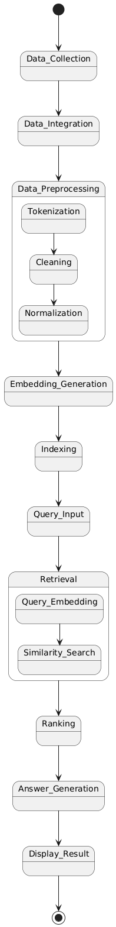
Fig 4.1 UML Diagram
Fig 4.1 outlines the sequential workflow of a Retrieval-Augmented Generation (RAG) system, beginning with Data Collection and Integration. The process moves into a Preprocessing phase, which involves tokenizing, cleaning, and normalizing the raw information to ensure data quality. This refined data is then converted into vector format during Embedding Generation and organized for efficient retrieval through Indexing. When a user provides a Query Input, the system executes a Retrieval process that includes embedding the query and performing a Similarity Search against the indexed data. Finally, the most relevant information is Ranked, used for Answer Generation, and presented to the user via the Display Result stage, completing the system's operational cycle.

4.2.2 SEQUENCE DIAGRAM
The sequence diagram describes the interaction flow between the user and the EduRAG system. The process begins when the user submits a query through the interface. The query is sent to the system backend, where it undergoes preprocessing and embedding generation. The generated query embedding is then used to retrieve relevant academic documents from the vector database. These documents are ranked based on similarity scores.
The retrieved content is passed to the lightweight language model, which generates an answer based on the provided context. The system then sends the generated response back to the user.
This sequence ensures efficient interaction and accurate answer generation. The sequence diagram is shown in Fig 4.2
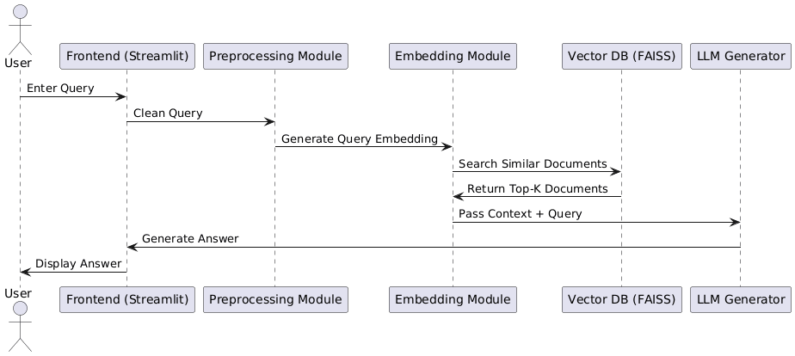
Fig 4.2 Sequence diagram
Fig 4.2 illustrates the real-time interaction between different system components during a user inquiry. The process initiates when a user enters a prompt through the Streamlit interface, which then routes the data to a preprocessing module for refinement. Once cleaned, the query is transformed into a numerical representation by the embedding module to facilitate a similarity search within the FAISS vector database. The database identifies and returns the most relevant document segments, which are then bundled with the original query and sent to the language model. This generator processes the provided context to formulate a coherent response, sending it back through the frontend to be viewed by the user. This flow effectively demonstrates how external data is retrieved and integrated to produce grounded, context-aware answers.

4.2.3 USE CASE DIAGRAM
The use case diagram illustrates user interaction with the EduRAG system.
The primary actor is the User (student/researcher).
Key use cases include:
- Upload or access academic dataset
- Enter query
- Retrieve relevant documents
- Generate answer
- View answer and supporting context
The system processes user queries, retrieves relevant content, and generates responses in an efficient and user-friendly manner. The use case diagram is shown in Fig 4.3

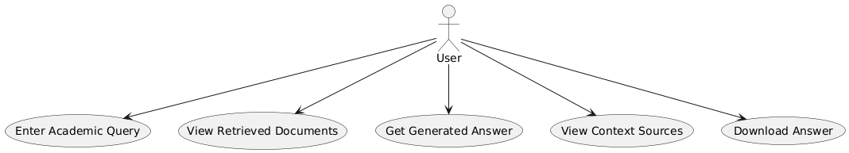
Fig 4.3 Use case Diagram
Fig 4.3 represents the primary interactions between the end user and the system. The workflow begins with the user providing an academic query, which triggers the system's retrieval and generation capabilities. Beyond simply receiving a generated response, the user can also inspect the specific documents retrieved by the system and examine the original context sources to verify information accuracy. Additionally, the interface provides functionality for the user to download the final answer for external use. This setup highlights a transparent and functional design tailored for academic research and documentation.

4.3 MODULE DESIGN AND ORGANISATION
The EduRAG system is divided into the following modules:
- Data Collection Module: Collect academic documents and datasets
- Data Integration Module: Combine documents with metadata
- Data Preprocessing Module: Clean and normalize text data
- Embedding Generation Module: Convert text into vector embeddings
- Retrieval Module: Retrieve relevant documents using similarity search
- Model Development Module: Implement lightweight language model
- Answer Generation Module: Generate context-aware responses
- User Interface Module: Provide interaction platform for users

4.4 SUMMARY
The EduRAG system is designed as a lightweight, scalable, and efficient academic question answering framework. It integrates text processing, embedding generation, retrieval mechanisms, and answer generation into a unified pipeline. The system follows a modular architecture, ensuring flexibility, scalability, and ease of maintenance. UML diagrams provide a clear representation of system workflows, interactions, and data flow, making the design easy to understand and implement. By combining retrieval and generation in an optimized manner, EduRAG reduces computational overhead while maintaining high accuracy and relevance. The system ensures fast response times and reliable answers, making it suitable for educational platforms and research applications. Overall, the EduRAG design provides a strong foundation for building an efficient academic QA system that meets the needs of modern learners and researchers.

CHAPTER-5

IMPLEMENTATION AND RESULTS

CHAPTER-5

IMPLEMENTATION AND RESULTS

INTRODUCTION
In the era of Artificial Intelligence advancements, the field of education and research is undergoing a significant transformation, particularly in the domain of academic question answering systems. This project aims to develop EduRAG, a lightweight Retrieval-Augmented Generation framework designed to provide accurate, context-aware, and efficient responses to academic queries. By leveraging natural language processing and retrieval-based techniques, the proposed system enhances knowledge access for students, researchers, and educators.
The implementation of EduRAG involves the integration of document retrieval mechanisms with lightweight generative models to develop an efficient academic QA system. Unlike traditional large-scale models, EduRAG focuses on reducing computational overhead while maintaining high relevance and accuracy. This chapter presents the systematic approach used to preprocess data, build the retrieval system, and generate answers effectively.
The dataset used in this project consists of academic documents, research papers, textbooks, and QA pairs, along with structured metadata. These datasets undergo multiple preprocessing steps before being used for embedding generation and indexing. The system is designed to handle large-scale textual data efficiently while ensuring fast retrieval and response generation.
The model development process includes text preprocessing, embedding generation, vector indexing, retrieval ranking, and answer generation. Lightweight embedding models such as MiniLM or Sentence Transformers are used to convert text into vector representations. The retrieval mechanism ensures that only the most relevant documents are used for answer generation, improving accuracy and reducing hallucination.
The evaluation of the system is based on metrics such as response relevance, retrieval accuracy, and latency, ensuring that the system delivers fast and meaningful answers. The generated responses are grounded in retrieved academic content, enhancing reliability and trustworthiness.
Finally, the system is deployed using a user-friendly interface, enabling users to input queries and receive answers in real time. This chapter provides a detailed explanation of the implementation process, system modules, and experimental outcomes of the EduRAG framework.

5.2 IMPLEMENTATION OF KEY FUNCTIONS
- Data Collection: The Data Collection module involves gathering academic resources from multiple sources, including research papers, textbooks, lecture notes, and academic QA datasets. The dataset is primarily text-based and may include structured metadata such as subject, topic, and keywords. These documents form the knowledge base of the EduRAG system and are essential for accurate retrieval and answer generation.
- Data Integration: The Data Integration module ensures that all collected documents and metadata are properly organized. This involves assigning each document a unique ID, linking metadata with corresponding documents, and removing duplicate or inconsistent entries. This step enables efficient retrieval and improves the system’s ability to provide contextually relevant answers.
- Data Preprocessing: Text preprocessing is essential for improving data quality and retrieval performance. The key steps include tokenization (splitting text into words or tokens), stop-word removal (eliminating irrelevant words), text normalization (lowercasing, stemming, or lemmatization), and noise removal (removing special characters and unwanted symbols). These steps ensure that the textual data is clean, consistent, and suitable for embedding generation.
- Embedding Generation: Embedding generation is a core component of EduRAG where documents are converted into vector representations. Lightweight models like MiniLM or Sentence Transformers are used to capture the semantic meaning of the text. These embeddings are stored in a vector database, enabling efficient similarity-based retrieval.
- Indexing And Retrieval Module: The indexing module stores embeddings using efficient search techniques such as FAISS or cosine similarity to facilitate fast nearest-neighbor search and top-k document retrieval. When a user query is entered, it is converted into an embedding and the system retrieves the most relevant documents, ensuring that only meaningful context is used for answer generation.
- Model Development Module: The model development module integrates retrieval with generation by using lightweight language models. Retrieved documents are passed as context to the model, and the system ensures answer grounding. This module forms the core pipeline of EduRAG, balancing efficiency and accuracy.
- Model Classification Module (QA Processing): Instead of standard classification, EduRAG performs context-aware answer generation. It processes user queries, retrieves relevant documents, and generates answers based on that context. This approach ensures that answers are informative and relevant to academic queries.
- Model Prediction Module: The prediction module generates responses for unseen queries. Given a user query as input, the system produces a generated answer plus supporting context as output. This ensures high relevance, reduced hallucination, and accurate academic responses.
- User Interface Module: The UI module provides an interactive platform for users. Key features include a query input field, the display of retrieved documents, generated answer output, and real-time response capabilities.
5.3 METHOD OF IMPLEMENTATION
File 1: EduRAG–Academic-QA.ipynb
#imports
import json
import os
from typing import List, Dict, Tuple
import warnings
warnings.filterwarnings('ignore')

# Core RAG Components
from sentence_transformers import SentenceTransformer
import faiss
import numpy as np
from transformers import AutoTokenizer, AutoModelForSeq2SeqLM
import torch

import json
from typing import List, Dict

class CollegeDataManager:
"""Manages college data loading and preparation."""

@staticmethod
def create_sample_data() -> List[Dict]:
"""Create structured college data for MITS."""

return [{
"category": "college_info",
"content": "Madanapalle Institute of Technology & Science (MITS) is a premier higher education institution established in 1998, located in Madanapalle, Annamayya District (formerly Chittoor District), Andhra Pradesh, India - PIN 517325."
},
{
"category": "college_info",
"content": "MITS is situated on a spacious 26.17-acre campus along the Madanapalle-Anantapur Highway (NH-205), near Angallu, approximately 10 km from Madanapalle town."
},
{
"category": "college_info",
"content": "MITS was founded under the Ratakonda Ranga Reddy Educational Academy, under the leadership of Late Sri N. Krishna Kumar, M.S. (U.S.A.), the then President, and Dr. N. Vijaya Bhaskar Choudary, Ph.D., the visionary leader of the Academy."
},
{
"category": "college_info",
"content": "MITS has been conferred the status of a Deemed to be University under Section 3 of the UGC Act, 1956, vide Notification No. 9-1/2025-U.3(A) dated 15th July, 2025. It is now officially known as MITS Deemed to be University."
},
{
"category": "college_info",
"content": "MITS Deemed to be University is governed by the visionary and proactive leadership of Dr. N. Vijaya Bhaskar Choudary, the founder and Chancellor, who is committed to establishing the institution as one of the foremost centers of academic excellence in India."
},
{
"category": "college_info",
"content": "With 27 years of academic excellence, MITS has earned NAAC A+ accreditation and NBA recognition for its programs, reflecting its commitment to quality standards and contributions to higher education."
},
{
"category": "college_info",
"content": "MITS has secured NIRF India Ranking 2025 in the band 201-300 under the National Institutional Framework, Ministry of Education, Government of India."
},
{
"category": "college_info",
"content": "MITS Deemed to be University has been honored with the prestigious Digital Skilling Excellence Award at the national level during the FutureSkills Prime – Digital Bharat Talent Conclave 2026 held in New Delhi."
},
{
"category": "college_info",
"content": "The institution's vision and mission is to serve the region, nation and world through academic excellence, research relevance, and community engagement while emphasizing the importance of the individual."
},
{
"category": "college_info",
"content": "MITS has global collaborations and MOUs with top universities worldwide including Asia University (Taiwan), Bowling Green State University (USA), and Kookmin University (South Korea) for global exposure and student exchange."
},

{
"category": "ug_programs",
"content": "B.Tech. - Computer Science & Engineering: Core computer science programme covering computing, algorithms, and system design."
},
{
"category": "ug_programs",
"content": "B.Tech. - CSE (Artificial Intelligence & Data Science): Specialized track in AI and Data Science with focus on machine intelligence, reasoning, and automation."
},
{
"category": "ug_programs",
"content": "B.Tech. - CSE (Artificial Intelligence & Machine Learning): Advanced programme in AI & ML focusing on data-driven intelligence and smart applications."
},
{
"category": "ug_programs",
"content": "B.Tech. - CSE (Artificial Intelligence & Robotics)*: Focus on artificial intelligence, machine learning, robotics, automation, and intelligent system design. (*New/Upcoming programme.)"
},
{
"category": "ug_programs",
"content": "B.Tech. - CSE (Cyber Security): Learn ethical hacking, secure systems, cryptography, and digital defense strategies."
},
{
"category": "ug_programs",
"content": "B.Tech. - Electronics & Communication Engineering: Learn communication systems, embedded electronics, and VLSI technology."
},
{
"category": "ug_programs",
"content": "B.Tech. - Electrical & Electronics Engineering: Power systems, electronics, and smart grids with real-world industry applications."
},
{
"category": "ug_programs",
"content": "B.Tech. - Mechanical Engineering: Design, manufacturing, and thermal engineering to build future innovations."
},
{
"category": "ug_programs",
"content": "B.Tech. - Civil Engineering: Learn the fundamentals of civil structures, construction, and sustainable development."
},
{
"category": "ug_programs",
"content": "B.Tech. - Bioinformatics: Explore computational tools and biological data to solve problems in genomics, drug discovery, and personalized medicine."
},
{
"category": "ug_programs",
"content": "B.Tech. - Civil & Machine Learning (CiML): An interdisciplinary programme combining civil engineering principles with machine learning applications."
},
{
"category": "ug_programs",
"content": "B.B.A. - Management Studies: Develop strong management and leadership skills with an emphasis on modern business practices and strategies."
},
{
"category": "ug_programs",
"content": "B.C.A. - Computer Applications: A strong foundation in computer applications and programming skills designed for careers in information technology."
},

{
"category": "pg_programs",
"content": "M.Tech. - VLSI & Embedded Systems (ECE): Advanced study of VLSI design and embedded systems for high-performance and intelligent electronic applications."
},
{
"category": "pg_programs",
"content": "M.Tech. - Civil Engineering (Construction Engineering and Management): Advanced learning in construction engineering and management for efficient planning, execution, and control of infrastructure projects."
},
{
"category": "pg_programs",
"content": "M.Tech. - Automation and Robotics (MECH): Advanced study of automation systems and robotics technologies for intelligent industrial applications."
},
{
"category": "pg_programs",
"content": "M.Tech. - Electric Vehicle Technology (EEE): Advanced industry-oriented training in electric vehicle design, battery management systems, and electric drive technologies."
},
{
"category": "pg_programs",
"content": "M.Tech. - Computer Science & Engineering: Advanced postgraduate education with a strong research focus in modern computer science technologies."
},
{
"category": "pg_programs",
"content": "M.Tech. - Computer Science & Engineering (AI & ML): Advanced postgraduate specialization and research in cutting-edge artificial intelligence and machine learning technologies."
},
{
"category": "pg_programs",
"content": "MBA - Master of Business Administration: Advanced management education focused on leadership, strategic thinking, and business decision-making."
},
{
"category": "pg_programs",
"content": "MCA - Master of Computer Applications: Advanced computing, programming, and application development for IT careers."
},

{
"category": "phd_programs",
"content": "MITS Deemed to be University offers Ph.D. research programmes for the January 2026 session under the Ph.D. Admission Notification 2025-26."
},
{
"category": "phd_programs",
"content": "Ph.D. research programmes are offered in the following disciplines: Civil Engineering, Electrical & Electronics Engineering, Mechanical Engineering, Electronics & Communication Engineering, Computer Science & Engineering, Computer Science, and Management."
},
{
"category": "phd_programs",
"content": "Ph.D. research programmes are also offered in the science and humanities disciplines of Physics*, Chemistry*, English*, and Mathematics* (subject to availability)."
},
{
"category": "phd_programs",
"content": "Eligibility for Ph.D. admission: Candidates must hold a postgraduate degree in the relevant discipline with a minimum of 55% marks or a CGPA of 5.5, OR an undergraduate degree in the relevant discipline with a minimum of 75% marks or a CGPA of 7.5."
},
{
"category": "phd_programs",
"content": "A relaxation of 5% marks is applicable for SC / ST / OBC / EWS candidates in Ph.D. eligibility criteria."
},
{
"category": "phd_programs",
"content": "Ph.D. selection procedure: Selection is based on an Entrance Test (MITS-DAT) and Interview. Candidates who have qualified NET/GATE/GPAT are exempted from the entrance test."
},
{
"category": "phd_programs",
"content": "Ph.D. Important Dates (Revised) for 2025-26 session: Online application opening – 28 January 2026; Online application closing – 28 February 2026; Entrance Test (MITS-DAT) – 07 March 2026; Interviews – 12 March 2026; Provisional Selection Announcement – 14 March 2026; Document verification and Reporting – 16 to 18 March 2026."
},
{
"category": "phd_programs",
"content": "For Ph.D. admissions enquiries, contact: deanresearch@mits.ac.in, adresearch@mits.ac.in, Phone: +91-7330945222, +91-9100777476. Detailed information is available at https://admission.mits.ac.in."
},

{
"category": "admissions",
"content": "MITS Admissions 2026 are open for UG (B.Tech, BBA, BCA), PG (M.Tech, MBA, MCA), and Ph.D. programmes. Up to 100% merit scholarships are available."
},
{
"category": "admissions",
"content": "Admission Process Step 1 – Registration: Fill the online application form with basic personal details at http://admission.mits.ac.in."
},
{
"category": "admissions",
"content": "Admission Process Step 2 – Verification: Verify your registered email address and mobile number via OTP."
},
{
"category": "admissions",
"content": "Admission Process Step 3 – Fill Application: Upload required documents and submit the completed application form."
},
{
"category": "admissions",
"content": "Admission Process Step 4 – Entrance Test: Appear for MITSUCET 2026 (MITS University Common Entrance Test), the university's own common entrance test."
},
{
"category": "admissions",
"content": "Admission Process Step 5 – Counseling: Attend counseling session and secure your seat in the chosen programme."
},
{
"category": "admissions",
"content": "MITSUCET 2026 Key Dates: Last Date to Apply – 31 March 2026; Announcement of Hall Ticket – 20 April 2026; Entrance Test – 3 May 2026; Merit List – TBA (To Be Announced)."
},
{
"category": "admissions",
"content": "For admissions, reach MITS at: Phone – 7330803555 / 7330852555, WhatsApp – 7330803555, Email – admissions@mits.ac.in, Website – http://admission.mits.ac.in."
},

{
"category": "academic_schools",
"content": "MITS Deemed to be University organizes its academic programmes under three schools: School of Engineering, School of Computing, and School of Management, offering a wide range of industry-aligned courses."
},

{
"category": "placements",
"content": "MITS is committed to 100% placement assistance and ensures that every student is equipped for a successful professional journey through distinguished faculty, state-of-the-art laboratories, and strong industry connections."
},
{
"category": "placements",
"content": "Top recruiters include leading companies such as Cognizant, Infosys, Morgan Stanley, and Inkers.ai, among others across various industry sectors."
},
{
"category": "placements",
"content": "Alumni testimonial – Shabaz Khan .N (B.Tech Civil, placed at Inkers.ai): The strong academic foundation, practical exposure, and guidance from faculty helped shape his technical and managerial skills, preparing him for leadership responsibilities."
},
{
"category": "placements",
"content": "Alumni testimonial – N. Shariq Nawaz Kh. (B.Tech CSE, placed at Morgan Stanley): MITS helped build a strong foundation in programming, problem-solving, and engineering concepts, with practical exposure and a collaborative environment that shaped his professional mindset."
},

{
"category": "facilities",
"content": "MITS campus spans 26.17 acres along the Madanapalle-Anantapur Highway (NH-205) with a ragging-free campus environment and vibrant campus life."
},
{
"category": "facilities",
"content": "The campus features newly constructed hostel blocks for both boys and girls with modern amenities, Wi-Fi connectivity, dining, and 24/7 security."
},
{
"category": "facilities",
"content": "State-of-the-art laboratories are available across all departments, equipped with advanced computing systems, research tools, and high-speed internet access to support both academic and research activities."
},
{
"category": "facilities",
"content": "The campus provides an equal and inclusive student community environment, emphasizing diversity and collaborative learning beyond academics."
},

{
"category": "events",
"content": "Ashv-2K26: A Two Day Techno Cultural Fest organized at MITS Deemed to be University on 25th and 26th March 2026 a new era begins."
},
{
"category": "events",
"content": "Faculty Development Program: A Six-Day Online Faculty Development Program on 'Next Generation Cyber Defense with Deep Learning' organized by the Department of CSE – Artificial Intelligence and Machine Learning, from 16th March to 21st March 2026 (6:00 PM to 7:30 PM, Virtual mode)."
},
{
"category": "events",
"content": "Technical Talk: A One Day Technical Talk on 'Fostering Innovation and Entrepreneurship in Engineering Education' organized by Departments of CSE-(AI) and CSE-(DS) under AICTE Sponsored DPS Scheme, held on 16th March 2026 (9:00 AM to 5:00 PM) at the Auditorium."
},

{
"category": "accreditations_rankings",
"content": "MITS holds NAAC A+ accreditation, reflecting its high standards of academic quality, infrastructure, and institutional governance."
},
{
"category": "accreditations_rankings",
"content": "Multiple programmes at MITS are accredited by the National Board of Accreditation (NBA), signifying compliance with outcome-based education standards."
},
{
"category": "accreditations_rankings",
"content": "MITS is ranked in the NIRF India Rankings 2025 band of 201-300 by the Ministry of Education, Government of India, under the National Institutional Ranking Framework."
},
{
"category": "accreditations_rankings",
"content": "MITS Deemed to be University is approved by AICTE (All India Council for Technical Education) and granted Deemed University status under Section 3 of the UGC Act, 1956."
},

{
"category": "contact",
"content": "Madanapalle Institute of Technology & Science (MITS Deemed to be University), Madanapalle-Kadiri Road, kurabalakota Mandal, Madanapalle – 517325, Annamayya District, Andhra Pradesh, India."
},
{
"category": "contact",
"content": "Phone: +91-8571-280255; 280706. Admissions Helpline: 7330803555 / 7330852555. WhatsApp: 7330803555."
},
{
"category": "contact",
"content": "Email: admissions@mits.ac.in. Official Website: https://www.mits.ac.in. Admissions Portal: https://admission.mits.ac.in."
},
{
"category": "contact",
"content": "Social Media: Facebook – https://www.facebook.com/mits_mpl, Instagram – https://www.instagram.com/mits_mpl, LinkedIn – https://www.linkedin.com/school/madanapalle-institute-of-technology-&-science/, YouTube available. Instagram handle: @mits_mpl."
},
{
"category": "contact",
"content": "MITS Radio 90.8 CRS is available for download on Google Play Store and Apple App Store."
}
]

@staticmethod
def save_to_json(data: List[Dict], filepath: str = "mits_data.json"):
"""Save data to JSON file."""
with open(filepath, 'w', encoding='utf-8') as f:
json.dump(data, f, indent=2, ensure_ascii=False)
print(f"✓ Data saved to {filepath}")

@staticmethod
def load_from_json(filepath: str = "mits_data.json") -> List[Dict]:
"""Load data from JSON file."""
with open(filepath, 'r', encoding='utf-8') as f:
data = json.load(f)
print(f"✓ Loaded {len(data)} documents from {filepath}")
return data
Output:
Created 68 records
✓ Data saved to mits_data.json
✓ Loaded 68 documents from mits_data.json

Sample record:
{'category': 'college_info', 'content': 'Madanapalle Institute of Technology & Science (MITS) is a premier higher education institution established in 1998, located in Madanapalle, Annamayya District (formerly Chittoor District), Andhra Pradesh, India - PIN 517325.'}

##Text chuking
class TextChunker:
"""Handles document chunking with overlap."""

def __init__(self, chunk_size: int = 400, overlap: int = 50):
"""
Initialize chunker.

Args:
chunk_size: Maximum tokens per chunk
overlap: Overlapping tokens between chunks
"""
self.chunk_size = chunk_size
self.overlap = overlap

def chunk_documents(self, documents: List[Dict]) -> List[Dict]:
"""
Chunk documents into smaller pieces.

For this implementation, since our documents are already appropriately
sized, we'll keep them as-is but add metadata.
"""
chunks = []
for idx, doc in enumerate(documents):
chunks.append({
"chunk_id": idx,
"content": doc["content"],
"category": doc["category"],
"metadata": {"source": "college_data", "doc_id": idx}
})

print(f"✓ Created {len(chunks)} chunks")
return chunks

##Embedding and Vector Store

class VectorStore:
"""FAISS-based vector store for semantic search."""

def __init__(self, embedding_model_name: str = "all-MiniLM-L6-v2"):
"""
Initialize vector store with embedding model.

Args:
embedding_model_name: Sentence transformer model name
"""
print(f"Loading embedding model: {embedding_model_name}...")
self.embedder = SentenceTransformer(embedding_model_name)
self.index = None
self.chunks = []
self.dimension = 384 # Dimension for all-MiniLM-L6-v2

def build_index(self, chunks: List[Dict]):
"""
Create FAISS index from document chunks.

Args:
chunks: List of document chunks with content
"""
self.chunks = chunks
texts = [chunk["content"] for chunk in chunks]

print("Generating embeddings...")
embeddings = self.embedder.encode(
texts,
show_progress_bar=True,
convert_to_numpy=True
)

# Create FAISS index (L2 distance)
self.index = faiss.IndexFlatL2(self.dimension)
self.index.add(embeddings.astype('float32'))

print(f"✓ FAISS index built with {self.index.ntotal} vectors")

def search(self, query: str, k: int = 3) -> List[Tuple[Dict, float]]:
"""
Search for top-k most relevant chunks.

Args:
query: User query string
k: Number of results to return

Returns:
List of (chunk, distance) tuples
"""
if self.index is None:
raise ValueError("Index not built. Call build_index() first.")

# Encode query
query_embedding = self.embedder.encode(
[query],
convert_to_numpy=True
).astype('float32')

# Search
distances, indices = self.index.search(query_embedding, k)

# Return chunks with scores
results = []
for dist, idx in zip(distances[0], indices[0]):
results.append((self.chunks[idx], float(dist)))

return results

##LLM Generator

class CampusRAGChatbot:
"""Complete RAG pipeline for campus information."""

def __init__(
self,
embedding_model: str = "all-MiniLM-L6-v2",
llm_model: str = "google/flan-t5-xl",
top_k: int = 3
):
"""
Initialize RAG chatbot.

Args:
embedding_model: Sentence transformer model
llm_model: LLM for generation
top_k: Number of chunks to retrieve
"""
self.vector_store = VectorStore(embedding_model)
self.generator = LLMGenerator(llm_model)
self.top_k = top_k

def setup(self, chunks: List[Dict]):
"""Build vector index from chunks."""
self.vector_store.build_index(chunks)

def query(self, question: str, verbose: bool = False) -> Dict:
"""
Process user query through RAG pipeline.

Args:
question: User question
verbose: Whether to show retrieval details

Returns:
Dictionary with answer and metadata
"""
# Step 1: Retrieve relevant chunks
results = self.vector_store.search(question, k=self.top_k)

# Step 2: Prepare context
context_parts = []
sources = []

for chunk, score in results:
context_parts.append(chunk["content"])
sources.append({
"category": chunk["category"],
"distance": score
})

context = "\n\n".join(context_parts)

if verbose:
print("\n" + "="*60)
print("RETRIEVED CONTEXT:")
print("="*60)
for i, (chunk, score) in enumerate(results, 1):
print(f"\n[Chunk {i}] Distance: {score:.4f}")
print(f"Category: {chunk['category']}")
print(f"Content: {chunk['content'][:200]}...")
print("="*60 + "\n")

# Step 3: Generate answer
answer = self.generator.generate_answer(question, context)

return {
"question": question,
"answer": answer,
"sources": sources,
"num_sources": len(sources)
}

def chat(self):
"""Interactive chat interface."""
print("\n" + "="*60)
print("🎓 Ekdant Institute of Technology - Campus Assistant")
print("="*60)
print("\nAsk me anything about the college!")
print("Type 'quit' or 'exit' to end the conversation.\n")

while True:
try:
question = input("You: ").strip()

if question.lower() in ['quit', 'exit', 'q']:
print("\nThank you for using the campus assistant. Goodbye! 👋\n")
break

if not question:
continue

print("\n🤖 Assistant: ", end="", flush=True)
result = self.query(question)
print(result["answer"])
print()

except KeyboardInterrupt:
print("\n\nGoodbye! 👋\n")
break
except Exception as e:
print(f"\n❌ Error: {e}\n")

##RAG Pipeline
class CampusRAGChatbot:
"""Complete RAG pipeline for campus information."""

def __init__(
self,
embedding_model: str = "all-MiniLM-L6-v2",
llm_model: str = "google/flan-t5-xl",
top_k: int = 3
):
"""
Initialize RAG chatbot.

Args:
embedding_model: Sentence transformer model
llm_model: LLM for generation
top_k: Number of chunks to retrieve
"""
self.vector_store = VectorStore(embedding_model)
self.generator = LLMGenerator(llm_model)
self.top_k = top_k

def setup(self, chunks: List[Dict]):
"""Build vector index from chunks."""
self.vector_store.build_index(chunks)

def query(self, question: str, verbose: bool = False) -> Dict:
"""
Process user query through RAG pipeline.

Args:
question: User question
verbose: Whether to show retrieval details

Returns:
Dictionary with answer and metadata
"""
# Step 1: Retrieve relevant chunks
results = self.vector_store.search(question, k=self.top_k)

# Step 2: Prepare context
context_parts = []
sources = []

for chunk, score in results:
context_parts.append(chunk["content"])
sources.append({
"category": chunk["category"],
"distance": score
})

context = "\n\n".join(context_parts)

if verbose:
print("\n" + "="*60)
print("RETRIEVED CONTEXT:")
print("="*60)
for i, (chunk, score) in enumerate(results, 1):
print(f"\n[Chunk {i}] Distance: {score:.4f}")
print(f"Category: {chunk['category']}")
print(f"Content: {chunk['content'][:200]}...")
print("="*60 + "\n")

# Step 3: Generate answer
answer = self.generator.generate_answer(question, context)

return {
"question": question,
"answer": answer,
"sources": sources,
"num_sources": len(sources)
}

def chat(self):
"""Interactive chat interface."""
print("\n" + "="*60)
print("🎓 Ekdant Institute of Technology - Campus Assistant")
print("="*60)
print("\nAsk me anything about the college!")
print("Type 'quit' or 'exit' to end the conversation.\n")

while True:
try:
question = input("You: ").strip()

if question.lower() in ['quit', 'exit', 'q']:
print("\nThank you for using the campus assistant. Goodbye! 👋\n")
break

if not question:
continue

print("\n🤖 Assistant: ", end="", flush=True)
result = self.query(question)
print(result["answer"])
print()

except KeyboardInterrupt:
print("\n\nGoodbye! 👋\n")
break
except Exception as e:
print(f"\n❌ Error: {e}\n")
##Main Execution
def main():
"""Main execution function."""

print("\n" + "="*70)
print(" CAMPUS RAG CHATBOT - INITIALIZATION")
print("="*70 + "\n")

# Step 1: Prepare data
print("Step 1: Preparing college data...")
data_manager = CollegeDataManager()
college_data = data_manager.create_sample_data()
data_manager.save_to_json(college_data)

# Step 2: Chunk documents
print("\nStep 2: Chunking documents...")
chunker = TextChunker(chunk_size=400, overlap=50)
chunks = chunker.chunk_documents(college_data)

# Step 3: Initialize RAG chatbot
print("\nStep 3: Initializing RAG pipeline...")
chatbot = CampusRAGChatbot(
embedding_model="all-MiniLM-L6-v2",
llm_model="google/flan-t5-xl",
top_k=3
)

# Step 4: Build vector index
print("\nStep 4: Building vector index...")
chatbot.setup(chunks)

print("\n" + "="*70)
print(" INITIALIZATION COMPLETE")
print("="*70 + "\n")

# Sample queries for demonstration
print("Running sample queries...\n")

sample_queries = [
"What courses are offered in AI?",
"What is the attendance policy?",
"Tell me about TechNova",
"What facilities are available in the library?",
"How many seats are there in B.Tech CSE?"
]

for query in sample_queries:
print(f"\n{'='*70}")
print(f"Q: {query}")
print('='*70)
result = chatbot.query(query, verbose=False)
print(f"A: {result['answer']}\n")

# Start interactive chat
chatbot.chat()

if __name__ == "__main__":
main()
=====================================================================
CAMPUS RAG CHATBOT - INITIALIZATION
======================================================================
Step 1: Preparing college data...
✓ Data saved to mits_data.json

Step 2: Chunking documents...
✓ Created 27 chunks

Step 3: Initializing RAG pipeline...
Loading embedding model: all-MiniLM-L6-v2...
modules.json: 100%
349/349 [00:00<00:00, 40.7kB/s]
Warning: You are sending unauthenticated requests to the HF Hub. Please set a HF_TOKEN to enable higher rate limits and faster downloads.
WARNING:huggingface_hub.utils._http:Warning: You are sending unauthenticated requests to the HF Hub. Please set a HF_TOKEN to enable higher rate limits and faster downloads.
config_sentence_transformers.json: 100%
116/116 [00:00<00:00, 11.0kB/s]
README.md:
10.5k/? [00:00<00:00, 960kB/s]
sentence_bert_config.json: 100%
53.0/53.0 [00:00<00:00, 4.65kB/s]
config.json: 100%
612/612 [00:00<00:00, 70.2kB/s]
model.safetensors: 100%
90.9M/90.9M [00:01<00:00, 458MB/s]
Loading weights: 100%
103/103 [00:00<00:00, 409.07it/s, Materializing param=pooler.dense.weight]
BertModel LOAD REPORT from: sentence-transformers/all-MiniLM-L6-v2
Key | Status | |
------------------------+------------+--+-
embeddings.position_ids | UNEXPECTED | |

Notes:
- UNEXPECTED :can be ignored when loading from different task/architecture; not ok if you expect identical arch.
tokenizer_config.json: 100%
350/350 [00:00<00:00, 36.5kB/s]
vocab.txt:
232k/? [00:00<00:00, 10.9MB/s]
tokenizer.json:
466k/? [00:00<00:00, 22.5MB/s]
special_tokens_map.json: 100%
112/112 [00:00<00:00, 8.55kB/s]
config.json: 100%
190/190 [00:00<00:00, 18.4kB/s]
Loading LLM: google/flan-t5-xl...
config.json:
1.44k/? [00:00<00:00, 135kB/s]
tokenizer_config.json:
2.54k/? [00:00<00:00, 214kB/s]
spiece.model: 100%
792k/792k [00:01<00:00, 3.95MB/s]
tokenizer.json:
2.42M/? [00:00<00:00, 57.3MB/s]
special_tokens_map.json:
2.20k/? [00:00<00:00, 230kB/s]
model.safetensors.index.json:
53.0k/? [00:00<00:00, 3.90MB/s]
Download complete: 100%
11.4G/11.4G [04:05<00:00, 26.4MB/s]
Fetching 2 files: 100%
2/2 [04:05<00:00, 245.85s/it]
Loading weights: 100%
558/558 [00:01<00:00, 566.45it/s, Materializing param=shared.weight]
The tied weights mapping and config for this model specifies to tie shared.weight to lm_head.weight, but both are present in the checkpoints, so we will NOT tie them. You should update the config with `tie_word_embeddings=False` to silence this warning
generation_config.json: 100%
147/147 [00:00<00:00, 8.65kB/s]
✓ Model loaded on cuda

Step 4: Building vector index...
Generating embeddings...
Batches: 100%
1/1 [00:00<00:00, 1.16it/s]
✓ FAISS index built with 27 vectors
Output:
======================================================================
INITIALIZATION COMPLETE
======================================================================

Running sample queries...

======================================================================
Q: What courses are offered in AI?
======================================================================
A: deep learning, big data analytics and real-world AI applications. The information is not available in the provided college datasets if you are looking for specific courses offered at this school."ref name="Text" align=alignno

======================================================================
Q: What is the attendance policy?
======================================================================
A: Students must maintain a minimum attendance of 75% to be eligible for semester examinations. The information is not available in the provided college data."ref name="TextBox" style=text-align:center

======================================================================
Q: Tell me about TechNova
======================================================================
A: The information is not available in the provided college data. You will need to do an internet search for MITS TechNova and then provide me with more specifics about it, such as:

======================================================================
Q: What facilities are available in the library?
======================================================================
A: digital resources, and e-learning facilities. Hostel Facilities are available for both boys And girls with Wifi; dining is also provided in the hostel which can be used by students

======================================================================
Q: How many seats are there in B.Tech CSE?
======================================================================
A: The information is not available in the provided college data. It's unclear if there are any seats left for CSE at this time or whether it will be offered again next year, so we cannot answer that question."

============================================================
🎓 Madanpalle Institute of Technology - Campus Assistant
============================================================

Ask me anything about the college!
Type 'quit' or 'exit' to end the conversation.

You: quit

Thank you for using the campus assistant. Goodbye! 👋
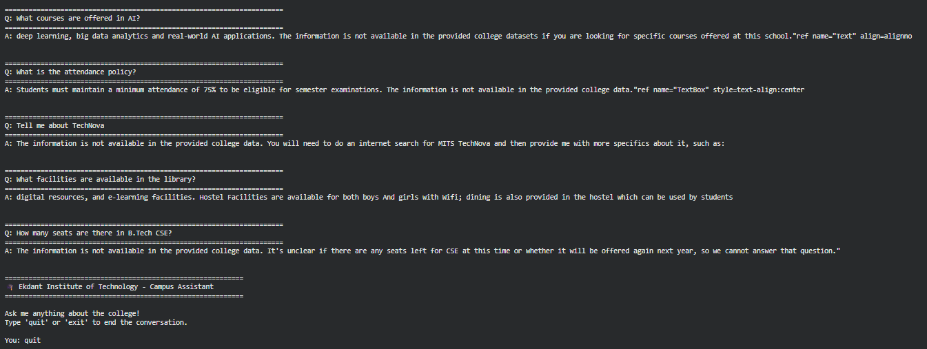
Fig 5.1 Output of the colab code
Fig 5.1 illustrates the system architecture of EduRAG, a lightweight Retrieval-Augmented Generation framework designed for academic question answering. The workflow begins with document processing, where PDF data is parsed into text chunks and converted into vector representations using an embedding model. These embeddings are stored in a FAISS vector database, enabling efficient similarity searches when a user submits a query. Finally, the system retrieves the most relevant context and passes it to a Large Language Model (LLM) to generate precise, fact-based answers tailored to academic needs.

Source Code for Testing:
##Testing

# ==========================================
# Initialize RAG Pipeline for Evaluation
# ==========================================

# Step 1: Prepare dataset
data_manager = CollegeDataManager()
college_data = data_manager.create_sample_data()

# Step 2: Chunk documents
chunker = TextChunker(chunk_size=400, overlap=50)
chunks = chunker.chunk_documents(college_data)

# Step 3: Initialize chatbot
chatbot = CampusRAGChatbot(
embedding_model="all-MiniLM-L6-v2",
llm_model="google/flan-t5-xl",
top_k=3
)

# Step 4: Build vector index
chatbot.setup(chunks)

print("RAG Chatbot Ready for Evaluation")

✓ Created 68 chunks
Loading embedding model: all-MiniLM-L6-v2...
Loading weights: 100%
103/103 [00:00<00:00, 512.56it/s, Materializing param=pooler.dense.weight]
BertModel LOAD REPORT from: sentence-transformers/all-MiniLM-L6-v2
Key | Status | |
------------------------+------------+--+-
embeddings.position_ids | UNEXPECTED | |

Notes:
- UNEXPECTED :can be ignored when loading from different task/architecture; not ok if you expect identical arch.
Loading LLM: google/flan-t5-xl...
Loading weights: 100%
558/558 [00:00<00:00, 739.31it/s, Materializing param=shared.weight]
The tied weights mapping and config for this model specifies to tie shared.weight to lm_head.weight, but both are present in the checkpoints, so we will NOT tie them. You should update the config with `tie_word_embeddings=False` to silence this warning
✓ Model loaded on cuda
Generating embeddings...
Batches: 100%
3/3 [00:00<00:00, 8.80it/s]
✓ FAISS index built with 68 vectors
RAG Chatbot Ready for Evaluation

# ==========================================
# Evaluation Dataset for Cross Validation (MITS)
# ==========================================

evaluation_dataset = [
# =========================
# Admissions
# =========================
{
"category": "Admissions",
"complexity": "Simple",
"query": "How can I apply for admission at MITS?",
"ground_truth": "Students must register online, verify details, fill the application, appear for MITSUCET, and attend counseling."
},
{
"category": "Admissions",
"complexity": "Technical",
"query": "What is MITSUCET?",
"ground_truth": "MITSUCET is the MITS University Common Entrance Test required for admission."
},
{
"category": "Admissions",
"complexity": "Specific",
"query": "What is the last date to apply for MITSUCET 2026?",
"ground_truth": "The last date to apply for MITSUCET 2026 is 31 March 2026."
},

# =========================
# College Info
# =========================
{
"category": "College Info",
"complexity": "Simple",
"query": "Where is MITS located?",
"ground_truth": "MITS is located in Madanapalle, Andhra Pradesh, India."
},
{
"category": "College Info",
"complexity": "Complex",
"query": "What is the status of MITS as a university?",
"ground_truth": "MITS has been granted Deemed to be University status under the UGC Act in 2025."
},
{
"category": "College Info",
"complexity": "Technical",
"query": "What accreditations does MITS have?",
"ground_truth": "MITS has NAAC A plus accreditation and NBA recognition for several programs."
},

# =========================
# Programs (UG / PG)
# =========================
{
"category": "Programs",
"complexity": "Multi-Entity",
"query": "What CSE specializations are available in MITS?",
"ground_truth": "CSE specializations include AI and Data Science, AI and Machine Learning, Cyber Security, and AI and Robotics."
},
{
"category": "Programs",
"complexity": "Simple",
"query": "Does MITS offer MBA and MCA programs?",
"ground_truth": "Yes, MITS offers MBA and MCA postgraduate programs."
},
{
"category": "Programs",
"complexity": "Complex",
"query": "What is the focus of the Bioinformatics program?",
"ground_truth": "The Bioinformatics program focuses on computational tools and biological data for genomics and drug discovery."
},

# =========================
# PhD Programs
# =========================
{
"category": "PhD",
"complexity": "Technical",
"query": "What is the eligibility for PhD admission?",
"ground_truth": "Candidates need a postgraduate degree with at least 55 percent marks or equivalent criteria."
},
{
"category": "PhD",
"complexity": "Complex",
"query": "What is the selection process for PhD at MITS?",
"ground_truth": "Selection involves an entrance test MITS-DAT and an interview, with exemptions for NET or GATE qualified candidates."
},

# =========================
# Facilities
# =========================
{
"category": "Facilities",
"complexity": "Simple",
"query": "Does MITS provide hostel facilities?",
"ground_truth": "Yes, hostel facilities are available for both boys and girls with modern amenities."
},
{
"category": "Facilities",
"complexity": "Multi-Entity",
"query": "What facilities are available on campus?",
"ground_truth": "Facilities include hostels, laboratories, Wi-Fi, sports infrastructure, and modern academic facilities."
},

# =========================
# Placements
# =========================
{
"category": "Placements",
"complexity": "Simple",
"query": "Does MITS provide placement assistance?",
"ground_truth": "Yes, MITS provides 100 percent placement assistance to students."
},
{
"category": "Placements",
"complexity": "Multi-Entity",
"query": "Which companies recruit students from MITS?",
"ground_truth": "Top recruiters include Cognizant, Infosys, Morgan Stanley, and Inkers.ai."
},

# =========================
# Events
# =========================
{
"category": "Events",
"complexity": "Specific",
"query": "What is Ashv-2K26?",
"ground_truth": "Ashv-2K26 is a two-day techno cultural fest held at MITS in March 2026."
},
{
"category": "Events",
"complexity": "Complex",
"query": "What academic events are conducted at MITS?",
"ground_truth": "MITS conducts workshops, faculty development programs, technical talks, and seminars."
},

# =========================
# Rankings & Recognition
# =========================
{
"category": "Ranking",
"complexity": "Technical",
"query": "What is the NIRF ranking of MITS?",
"ground_truth": "MITS is ranked in the 201 to 300 band in NIRF 2025."
},

# =========================
# Contact
# =========================
{
"category": "Contact",
"complexity": "Simple",
"query": "How can I contact MITS admissions?",
"ground_truth": "You can contact admissions via phone, email admissions at mits dot ac dot in, or the official website."
}
]

print("Cross Validation Dataset Size:", len(evaluation_dataset))

# ==========================================
# Correct RAG Evaluation
# ==========================================

import time
import numpy as np
import pandas as pd
from nltk.translate.bleu_score import sentence_bleu, SmoothingFunction

smooth = SmoothingFunction().method1

results = []

for item in evaluation_dataset:

query = item["query"]
ground_truth = item["ground_truth"]

start = time.time()
response = chatbot.query(query)
latency = time.time() - start

answer = response["answer"]

# CORRECT CONTEXT EXTRACTION
retrieved_context = " ".join(
[chunk["content"] for chunk, score in chatbot.vector_store.search(query, k=3)]
)

# embeddings
embeddings = semantic_model.encode([answer, ground_truth, retrieved_context])

ans_vec = embeddings[0]
gt_vec = embeddings[1]
ctx_vec = embeddings[2]

# cosine similarity
relevance = np.dot(ans_vec, gt_vec) / (
np.linalg.norm(ans_vec) * np.linalg.norm(gt_vec)
)

faithfulness = np.dot(ans_vec, ctx_vec) / (
np.linalg.norm(ans_vec) * np.linalg.norm(ctx_vec)
)

bleu = sentence_bleu(
[ground_truth.split()],
answer.split(),
smoothing_function=smooth
)

results.append({
"Test Category": item["category"],
"Query Complexity": item["complexity"],
"Faithfulness": round(float(faithfulness),2),
"Answer Relevance": round(float(relevance),2),
"BLEU Score": round(float(bleu),2),
"Latency (s)": round(latency,2)
})

df_results = pd.DataFrame(results)
df_result

5.4 Frontend & Backend Implementation
The following are the screenshots of the project created using Python, Fast API, React, Tailwind CSS.
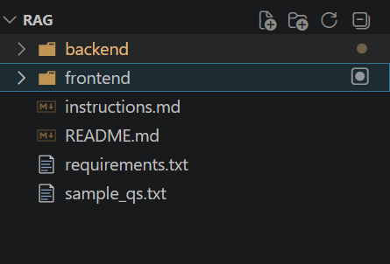
Fig 5.2 Project Root Folder Structure
Fig 5.2 shows the overall root directory structure of the EduRAG project. It includes the main folders such as backend and frontend, along with supporting files like README and requirements. The structure reflects a modular organization separating core functionalities. This layout improves maintainability, scalability, and ease of development.
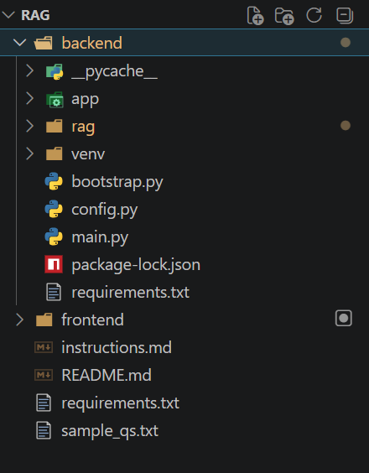
Fig 5.3 Backend Directory Structure
Fig 5.3 illustrates the internal organization of the backend module of the EduRAG system. It includes folders for application logic, RAG processing, and environment setup, along with key Python files such as main.py and configuration files. The structure supports efficient API handling and model integration. This modular backend design ensures clarity and ease of extension.
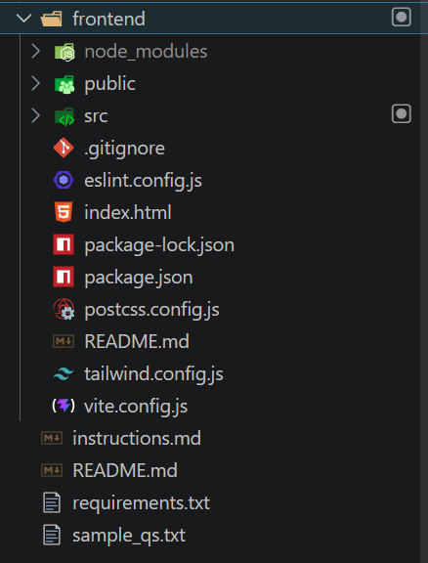
Fig 5.4 Frontend Directory Structure
Fig 5.4 presents the structure of the frontend application built using modern web technologies. It includes directories such as src, public, and node_modules, along with configuration files like package.json and Tailwind CSS settings. The structure supports component-based development and efficient UI management. This organization enhances scalability and maintainability of the user interface.

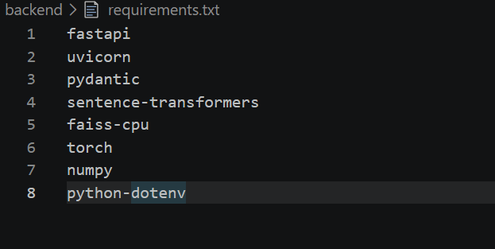
Fig 5.5 Backend Requirements File
Fig 5.5 displays the requirements.txt file containing all necessary backend dependencies. It includes libraries such as FastAPI, Uvicorn, Sentence Transformers, FAISS, and PyTorch. These packages enable API development, embedding generation, and retrieval operations. The file ensures consistent environment setup and simplifies project deployment.

Backend
File 2:bootstrap.py
backend/bootstrap.py

from rag.data_manager import CollegeDataManager
from rag.chunker import TextChunker
from rag.pipeline import CampusRAGChatbot

def initialize_chatbot():
data = CollegeDataManager.create_sample_data()
chunker = TextChunker()
chunks = chunker.chunk_documents(data)

chatbot = CampusRAGChatbot()
chatbot.setup(chunks)

return chatbot
File 3: main.py
backend/main.py

from bootstrap import initialize_chatbot

if __name__ == "__main__":
bot = initialize_chatbot()
response = bot.query("What courses are offered in AI?")
print(response["answer"])
File 4: main.py
backend/app/main.py

from fastapi import FastAPI
from fastapi.middleware.cors import CORSMiddleware
from app.api import router
from app.state import state
from bootstrap import initialize_chatbot

app = FastAPI(
title="EduRAG API",
description="Campus Information RAG Service",
version="1.0.0"
)

# ✅ ADD THIS BLOCK
app.add_middleware(
CORSMiddleware,
allow_origins=[
"http://localhost:5173",
"http://localhost:5174",
"https://edurag-iota.vercel.app/"
],
allow_credentials=True,
allow_methods=["*"],
allow_headers=["*"],
)

@app.on_event("startup")
def startup_event():
state.chatbot = initialize_chatbot()

app.include_router(router)

File 5: api.py
backend/app/api.py

from fastapi import APIRouter, HTTPException
from app.schemas import ChatRequest, ChatResponse
from app.state import state

router = APIRouter()

@router.post("/chat", response_model=ChatResponse)
def chat_endpoint(payload: ChatRequest):
if state.chatbot is None:
raise HTTPException(status_code=503, detail="Chatbot not initialized")

result = state.chatbot.query(payload.query)
return result
File 6: schemas.py
backend/app/schemas.py

from pydantic import BaseModel
from typing import List

class ChatRequest(BaseModel):
query: str

class Source(BaseModel):
category: str
distance: float

class ChatResponse(BaseModel):
question: str
answer: str
sources: List[Source]
File 7: state.py
backend/app/state.py

from typing import Optional
from rag.pipeline import CampusRAGChatbot

class AppState:
chatbot: Optional[CampusRAGChatbot] = None

state = AppState()
File 8: data_manager.py
backend/rag/data_manager.py

from typing import List, Dict
import json

class CollegeDataManager:
"""Manages college data loading and preparation."""

@staticmethod
def create_sample_data() -> List[Dict]:
return [
{
"category": "college_info",
"content": "Madanapalle Institute of Technology & Science (MITS) is a premier higher education institution established in 1998, located in Madanapalle, Annamayya District (formerly Chittoor District), Andhra Pradesh, India - PIN 517325."
},
{
"category": "college_info",
"content": "MITS is situated on a spacious 26.17-acre campus along the Madanapalle-Anantapur Highway (NH-205), near Angallu, approximately 10 km from Madanapalle town."
},
{
"category": "college_info",
"content": "MITS was founded under the Ratakonda Ranga Reddy Educational Academy, under the leadership of Late Sri N. Krishna Kumar, M.S. (U.S.A.), the then President, and Dr. N. Vijaya Bhaskar Choudary, Ph.D., the visionary leader of the Academy."
},
{
"category": "college_info",
"content": "MITS has been conferred the status of a Deemed to be University under Section 3 of the UGC Act, 1956, vide Notification No. 9-1/2025-U.3(A) dated 15th July, 2025. It is now officially known as MITS Deemed to be University."
},
{
"category": "college_info",
"content": "MITS Deemed to be University is governed by the visionary and proactive leadership of Dr. N. Vijaya Bhaskar Choudary, the founder and Chancellor, who is committed to establishing the institution as one of the foremost centers of academic excellence in India."
},
{
"category": "college_info",
"content": "With 27 years of academic excellence, MITS has earned NAAC A+ accreditation and NBA recognition for its programs, reflecting its commitment to quality standards and contributions to higher education."
},
{
"category": "college_info",
"content": "MITS has secured NIRF India Ranking 2025 in the band 201-300 under the National Institutional Framework, Ministry of Education, Government of India."
},
{
"category": "college_info",
"content": "MITS Deemed to be University has been honored with the prestigious Digital Skilling Excellence Award at the national level during the FutureSkills Prime - Digital Bharat Talent Conclave 2026 held in New Delhi."
},
{
"category": "college_info",
"content": "The institution's vision and mission is to serve the region, nation and world through academic excellence, research relevance, and community engagement while emphasizing the importance of the individual."
},
{
"category": "college_info",
"content": "MITS has global collaborations and MOUs with top universities worldwide including Asia University (Taiwan), Bowling Green State University (USA), and Kookmin University (South Korea) for global exposure and student exchange."
},
{
"category": "ug_programs",
"content": "B.Tech. - Computer Science & Engineering: Core computer science programme covering computing, algorithms, and system design."
},
{
"category": "ug_programs",
"content": "B.Tech. - CSE (Artificial Intelligence & Data Science): Specialized track in AI and Data Science with focus on machine intelligence, reasoning, and automation."
},
{
"category": "ug_programs",
"content": "B.Tech. - CSE (Artificial Intelligence & Machine Learning): Advanced programme in AI & ML focusing on data-driven intelligence and smart applications."
},
{
"category": "ug_programs",
"content": "B.Tech. - CSE (Artificial Intelligence & Robotics)*: Focus on artificial intelligence, machine learning, robotics, automation, and intelligent system design. (*New/Upcoming programme.)"
},
{
"category": "ug_programs",
"content": "B.Tech. - CSE (Cyber Security): Learn ethical hacking, secure systems, cryptography, and digital defense strategies."
},
{
"category": "ug_programs",
"content": "B.Tech. - Electronics & Communication Engineering: Learn communication systems, embedded electronics, and VLSI technology."
},
{
"category": "ug_programs",
"content": "B.Tech. - Electrical & Electronics Engineering: Power systems, electronics, and smart grids with real-world industry applications."
},
{
"category": "ug_programs",
"content": "B.Tech. - Mechanical Engineering: Design, manufacturing, and thermal engineering to build future innovations."
},
{
"category": "ug_programs",
"content": "B.Tech. - Civil Engineering: Learn the fundamentals of civil structures, construction, and sustainable development."
},
{
"category": "ug_programs",
"content": "B.Tech. - Bioinformatics: Explore computational tools and biological data to solve problems in genomics, drug discovery, and personalized medicine."
},
{
"category": "ug_programs",
"content": "B.Tech. - Civil & Machine Learning (CiML): An interdisciplinary programme combining civil engineering principles with machine learning applications."
},
{
"category": "ug_programs",
"content": "B.B.A. - Management Studies: Develop strong management and leadership skills with an emphasis on modern business practices and strategies."
},
{
"category": "ug_programs",
"content": "B.C.A. - Computer Applications: A strong foundation in computer applications and programming skills designed for careers in information technology."
},
{
"category": "pg_programs",
"content": "M.Tech. - VLSI & Embedded Systems (ECE): Advanced study of VLSI design and embedded systems for high-performance and intelligent electronic applications."
},
{
"category": "pg_programs",
"content": "M.Tech. - Civil Engineering (Construction Engineering and Management): Advanced learning in construction engineering and management for efficient planning, execution, and control of infrastructure projects."
},
{
"category": "pg_programs",
"content": "M.Tech. - Automation and Robotics (MECH): Advanced study of automation systems and robotics technologies for intelligent industrial applications."
},
{
"category": "pg_programs",
"content": "M.Tech. - Electric Vehicle Technology (EEE): Advanced industry-oriented training in electric vehicle design, battery management systems, and electric drive technologies."
},
{
"category": "pg_programs",
"content": "M.Tech. - Computer Science & Engineering: Advanced postgraduate education with a strong research focus in modern computer science technologies."
},
{
"category": "pg_programs",
"content": "M.Tech. - Computer Science & Engineering (AI & ML): Advanced postgraduate specialization and research in cutting-edge artificial intelligence and machine learning technologies."
},
{
"category": "pg_programs",
"content": "MBA - Master of Business Administration: Advanced management education focused on leadership, strategic thinking, and business decision-making."
},
{
"category": "pg_programs",
"content": "MCA - Master of Computer Applications: Advanced computing, programming, and application development for IT careers."
},
{
"category": "phd_programs",
"content": "MITS Deemed to be University offers Ph.D. research programmes for the January 2026 session under the Ph.D. Admission Notification 2025-26."
},
{
"category": "phd_programs",
"content": "Ph.D. research programmes are offered in the following disciplines: Civil Engineering, Electrical & Electronics Engineering, Mechanical Engineering, Electronics & Communication Engineering, Computer Science & Engineering, Computer Science, and Management."
},
{
"category": "phd_programs",
"content": "Ph.D. research programmes are also offered in the science and humanities disciplines of Physics*, Chemistry*, English*, and Mathematics* (subject to availability)."
},
{
"category": "phd_programs",
"content": "Eligibility for Ph.D. admission: Candidates must hold a postgraduate degree in the relevant discipline with a minimum of 55% marks or a CGPA of 5.5, OR an undergraduate degree in the relevant discipline with a minimum of 75% marks or a CGPA of 7.5."
},
{
"category": "phd_programs",
"content": "A relaxation of 5% marks is applicable for SC / ST / OBC / EWS candidates in Ph.D. eligibility criteria."
},
{
"category": "phd_programs",
"content": "Ph.D. selection procedure: Selection is based on an Entrance Test (MITS-DAT) and Interview. Candidates who have qualified NET/GATE/GPAT are exempted from the entrance test."
},
{
"category": "phd_programs",
"content": "Ph.D. Important Dates (Revised) for 2025-26 session: Online application opening - 28 January 2026; Online application closing - 28 February 2026; Entrance Test (MITS-DAT) - 07 March 2026; Interviews - 12 March 2026; Provisional Selection Announcement - 14 March 2026; Document verification and Reporting - 16 to 18 March 2026."
},
{
"category": "phd_programs",
"content": "For Ph.D. admissions enquiries, contact: deanresearch@mits.ac.in, adresearch@mits.ac.in, Phone: +91-7330945222, +91-9100777476. Detailed information is available at https://admission.mits.ac.in."
},
{
"category": "admissions",
"content": "MITS Admissions 2026 are open for UG (B.Tech, BBA, BCA), PG (M.Tech, MBA, MCA), and Ph.D. programmes. Up to 100% merit scholarships are available."
},
{
"category": "admissions",
"content": "Admission Process Step 1 - Registration: Fill the online application form with basic personal details at http://admission.mits.ac.in."
},
{
"category": "admissions",
"content": "Admission Process Step 2 - Verification: Verify your registered email address and mobile number via OTP."
},
{
"category": "admissions",
"content": "Admission Process Step 3 - Fill Application: Upload required documents and submit the completed application form."
},
{
"category": "admissions",
"content": "Admission Process Step 4 - Entrance Test: Appear for MITSUCET 2026 (MITS University Common Entrance Test), the university's own common entrance test."
},
{
"category": "admissions",
"content": "Admission Process Step 5 - Counseling: Attend counseling session and secure your seat in the chosen programme."
},
{
"category": "admissions",
"content": "MITSUCET 2026 Key Dates: Last Date to Apply - 31 March 2026; Announcement of Hall Ticket - 20 April 2026; Entrance Test - 3 May 2026; Merit List - TBA (To Be Announced)."
},
{
"category": "admissions",
"content": "For admissions, reach MITS at: Phone - 7330803555 / 7330852555, WhatsApp - 7330803555, Email - admissions@mits.ac.in, Website - http://admission.mits.ac.in."
},
{
"category": "academic_schools",
"content": "MITS Deemed to be University organizes its academic programmes under three schools: School of Engineering, School of Computing, and School of Management, offering a wide range of industry-aligned courses."
},
{
"category": "placements",
"content": "MITS is committed to 100% placement assistance and ensures that every student is equipped for a successful professional journey through distinguished faculty, state-of-the-art laboratories, and strong industry connections."
},
{
"category": "placements",
"content": "Top recruiters include leading companies such as Cognizant, Infosys, Morgan Stanley, and Inkers.ai, among others across various industry sectors."
},
{
"category": "placements",
"content": "Alumni testimonial - Shabaz Khan .N (B.Tech Civil, placed at Inkers.ai): The strong academic foundation, practical exposure, and guidance from faculty helped shape his technical and managerial skills, preparing him for leadership responsibilities."
},
{
"category": "placements",
"content": "Alumni testimonial - N. Shariq Nawaz Kh. (B.Tech CSE, placed at Morgan Stanley): MITS helped build a strong foundation in programming, problem-solving, and engineering concepts, with practical exposure and a collaborative environment that shaped his professional mindset."
},
{
"category": "facilities",
"content": "MITS campus spans 26.17 acres along the Madanapalle-Anantapur Highway (NH-205) with a ragging-free campus environment and vibrant campus life."
},
{
"category": "facilities",
"content": "The campus features newly constructed hostel blocks for both boys and girls with modern amenities, Wi-Fi connectivity, dining, and 24/7 security."
},
{
"category": "facilities",
"content": "State-of-the-art laboratories are available across all departments, equipped with advanced computing systems, research tools, and high-speed internet access to support both academic and research activities."
},
{
"category": "facilities",
"content": "The campus provides an equal and inclusive student community environment, emphasizing diversity and collaborative learning beyond academics."
},
{
"category": "events",
"content": "Ashv-2K26: A Two Day Techno Cultural Fest organized at MITS Deemed to be University on 25th and 26th March 2026 - a new era begins."
},
{
"category": "events",
"content": "Faculty Development Program: A Six-Day Online Faculty Development Program on 'Next Generation Cyber Defense with Deep Learning' organized by the Department of CSE - Artificial Intelligence and Machine Learning, from 16th March to 21st March 2026 (6:00 PM to 7:30 PM, Virtual mode)."
},
{
"category": "events",
"content": "Technical Talk: A One Day Technical Talk on 'Fostering Innovation and Entrepreneurship in Engineering Education' organized by Departments of CSE-(AI) and CSE-(DS) under AICTE Sponsored DPS Scheme, held on 16th March 2026 (9:00 AM to 5:00 PM) at the Auditorium."
},
{
"category": "accreditations_rankings",
"content": "MITS holds NAAC A+ accreditation, reflecting its high standards of academic quality, infrastructure, and institutional governance."
},
{
"category": "accreditations_rankings",
"content": "Multiple programmes at MITS are accredited by the National Board of Accreditation (NBA), signifying compliance with outcome-based education standards."
},
{
"category": "accreditations_rankings",
"content": "MITS is ranked in the NIRF India Rankings 2025 band of 201-300 by the Ministry of Education, Government of India, under the National Institutional Ranking Framework."
},
{
"category": "accreditations_rankings",
"content": "MITS Deemed to be University is approved by AICTE (All India Council for Technical Education) and granted Deemed University status under Section 3 of the UGC Act, 1956."
},
{
"category": "contact",
"content": "Madanapalle Institute of Technology & Science (MITS Deemed to be University), Madanapalle-Kadiri Road, kurabalakota Mandal, Madanapalle - 517325, Annamayya District, Andhra Pradesh, India."
},
{
"category": "contact",
"content": "Phone: +91-8571-280255; 280706. Admissions Helpline: 7330803555 / 7330852555. WhatsApp: 7330803555."
},
{
"category": "contact",
"content": "Email: admissions@mits.ac.in. Official Website: https://www.mits.ac.in. Admissions Portal: https://admission.mits.ac.in."
},
{
"category": "contact",
"content": "Social Media: Facebook - https://www.facebook.com/mits_mpl, Instagram - https://www.instagram.com/mits_mpl, LinkedIn - https://www.linkedin.com/school/madanapalle-institute-of-technology-&-science/, YouTube available. Instagram handle: @mits_mpl."
},
{
"category": "contact",
"content": "MITS Radio 90.8 CRS is available for download on Google Play Store and Apple App Store."
}
]

@staticmethod
def save_to_json(data: List[Dict], filepath: str):
with open(filepath, "w", encoding="utf-8") as f:
json.dump(data, f, indent=2, ensure_ascii=False)

@staticmethod
def load_from_json(filepath: str) -> List[Dict]:
with open(filepath, "r", encoding="utf-8") as f:
return json.load(f)
File 9: chunker.py
backend/rag/chunker.py

from typing import List, Dict

class TextChunker:
"""Handles document chunking with overlap."""

def __init__(self, chunk_size: int = 400, overlap: int = 50):
self.chunk_size = chunk_size
self.overlap = overlap

def chunk_documents(self, documents: List[Dict]) -> List[Dict]:
chunks = []

for idx, doc in enumerate(documents):
chunks.append({
"chunk_id": idx,
"content": doc["content"],
"category": doc["category"],
"metadata": {
"source": "college_data",
"doc_id": idx
}
})

return chunks
File 10: vector_store.py
backend/rag/vector_store.py

from typing import List, Dict, Tuple
import faiss
import numpy as np
from sentence_transformers import SentenceTransformer

class VectorStore:
"""FAISS-based vector store for semantic search."""

def __init__(self, embedding_model_name: str = "all-MiniLM-L6-v2"):
self.embedder = SentenceTransformer(embedding_model_name)
self.index = None
self.chunks: List[Dict] = []
self.dimension = 384

def build_index(self, chunks: List[Dict]):
self.chunks = chunks
texts = [chunk["content"] for chunk in chunks]

embeddings = self.embedder.encode(
texts,
show_progress_bar=True,
convert_to_numpy=True
).astype("float32")

self.index = faiss.IndexFlatL2(self.dimension)
self.index.add(embeddings)

def search(self, query: str, k: int = 3) -> List[Tuple[Dict, float]]:
if self.index is None:
raise RuntimeError("FAISS index not initialized")

query_embedding = self.embedder.encode(
[query],
convert_to_numpy=True
).astype("float32")

distances, indices = self.index.search(query_embedding, k)

results = []
for dist, idx in zip(distances[0], indices[0]):
results.append((self.chunks[idx], float(dist)))

return results
File 11: generator.py
backend/rag/generator.py

import torch
from transformers import AutoTokenizer, AutoModelForSeq2SeqLM

class LLMGenerator:
"""Lightweight LLM for answer generation."""

def __init__(self, model_name: str = "google/flan-t5-xl"):
self.tokenizer = AutoTokenizer.from_pretrained(model_name)
self.model = AutoModelForSeq2SeqLM.from_pretrained(model_name)

self.device = "cuda" if torch.cuda.is_available() else "cpu"
self.model.to(self.device)

def generate_answer(self, query: str, context: str) -> str:
prompt = f"""
You are a helpful campus assistant.
Using ONLY the information provided in the context,
write a complete, well-formed answer in natural language.
If the answer is not present, say:
"The information is not available in the provided college data."

Context:
{context}

Question:
{query}

Answer:
"""

inputs = self.tokenizer(
prompt,
max_length=512,
truncation=True,
return_tensors="pt"
).to(self.device)

outputs = self.model.generate(
**inputs,
max_length=200,
min_length=40,
num_beams=4,
repetition_penalty=1.2,
no_repeat_ngram_size=3,
early_stopping=True
)

return self.tokenizer.decode(
outputs[0],
skip_special_tokens=True
).strip()
File 12: pipeline.py
backend/rag/pipeline.py

from typing import Dict
from .vector_store import VectorStore
from .generator import LLMGenerator

class CampusRAGChatbot:
"""Complete RAG pipeline for campus information."""

def __init__(
self,
embedding_model: str = "all-MiniLM-L6-v2",
llm_model: str = "google/flan-t5-base",
top_k: int = 3
):
self.vector_store = VectorStore(embedding_model)
self.generator = LLMGenerator(llm_model)
self.top_k = top_k

def setup(self, chunks):
self.vector_store.build_index(chunks)

def query(self, question: str) -> Dict:
results = self.vector_store.search(question, k=self.top_k)

context_parts = []
sources = []

for chunk, score in results:
context_parts.append(chunk["content"])
sources.append({
"category": chunk["category"],
"distance": score
})

context = "\n\n".join(context_parts)
answer = self.generator.generate_answer(question, context)

return {
"question": question,
"answer": answer,
"sources": sources
}
```

Frontend
File 13: main.jsx
frontend/src/main.jsx

import { StrictMode } from 'react'
import { createRoot } from 'react-dom/client'
import './index.css'
import App from './App.jsx'

createRoot(document.getElementById('root')).render(
<StrictMode>
<App />
</StrictMode>,
)
File 14: App.jsx
frontend/src/App.jsx

import ChatPage from "./pages/ChatPage";

export default function App() {
return <ChatPage />;
}
```
File 15: App.css
frontend/src/App.css

#root {
max-width: 1280px;
margin: 0 auto;
padding: 2rem;
text-align: center;
}

.logo {
height: 6em;
padding: 1.5em;
will-change: filter;
transition: filter 300ms;
}
.logo:hover {
filter: drop-shadow(0 0 2em #646cffaa);
}
.logo.react:hover {
filter: drop-shadow(0 0 2em #61dafbaa);
}

@keyframes logo-spin {
from {
transform: rotate(0deg);
}
to {
transform: rotate(360deg);
}
}

@media (prefers-reduced-motion: no-preference) {
a:nth-of-type(2) .logo {
animation: logo-spin infinite 20s linear;
}
}

.card {
padding: 2em;
}

.read-the-docs {
color: #888;
}
File 16: index.css
frontend/src/index.css

@import "tailwindcss";
@tailwind base;
@tailwind components;
@tailwind utilities;

body {
@apply bg-slate-50 text-slate-900 antialiased;
}
File 17: ChatPage.jsx
frontend/src/pages/ChatPage.jsx

import ChatContainer from "../components/ChatContainer";

export default function ChatPage() {
return (
<div className="min-h-screen flex items-center justify-center">
<ChatContainer />
</div>
);
}
File 18: api.js
frontend/src/services/api.js
import axios from "axios";

const API_BASE = "http://127.0.0.1:8000";

export async function sendChatMessage(query) {
const response = await axios.post(`${API_BASE}/chat`, {
query,
});
return response.data;
}
File 19:ChatContainer.jsx
frontend/src/components/ChatContainer.jsx

import { useState } from "react";
import ChatHeader from "./ChatHeader";
import ChatMessages from "./ChatMessages";
import ChatInput from "./ChatInput";
import { sendChatMessage } from "../services/api";

function cleanAnswer(answer) {
const fallback = "The information is not available in the provided college data.";
return answer.replace(fallback, "").trim();
}

export default function ChatContainer() {
const [messages, setMessages] = useState([]);
const [loading, setLoading] = useState(false);

async function handleSend(query) {
if (!query.trim()) return;

setMessages((prev) => [...prev, { role: "user", text: query }]);
setLoading(true);

try {
const data = await sendChatMessage(query);
setMessages((prev) => [
...prev,
{
role: "assistant",
text: cleanAnswer(data.answer),
sources: data.sources,
},
]);
} catch {
setMessages((prev) => [
...prev,
{ role: "assistant", text: "Something went wrong. Please try again." },
]);
} finally {
setLoading(false);
}
}

return (
<div className="w-full max-w-3xl h-[85vh] bg-slate-900 rounded-2xl shadow-xl flex flex-col">
<ChatHeader />
<ChatMessages messages={messages} loading={loading} />
<ChatInput onSend={handleSend} disabled={loading} />
</div>
);
}
File 20:ChatMessages.jsx
frontend/src/components/ChatMessages.jsx

import { useEffect, useRef } from "react";
import TypingIndicator from "./TypingIndicator";
import MessageBubble from "./MessageBubble";

export default function ChatMessages({ messages, loading }) {
const bottomRef = useRef(null);

useEffect(() => {
bottomRef.current?.scrollIntoView({ behavior: "smooth" });
}, [messages, loading]);

return (
<div className="flex-1 px-6 py-4 overflow-y-auto">
{messages.map((msg, idx) => (
<MessageBubble key={idx} {...msg} />
))}

{loading && <TypingIndicator />}

<div ref={bottomRef} />
</div>
);
}
File 21:ChatInput.jsx
frontend/src/components/ChatInput.jsx
import { useState } from "react";

const FOOTER_QUESTIONS = [
"How can I apply for admission at MITS?",
"What is MITSUCET?",
"What is the last date to apply for MITSUCET 2026?",
"Where is MITS located?",
"What is the status of MITS as a university?",
"What accreditations does MITS have?",
"What CSE specializations are available in MITS?",
"Does MITS offer MBA and MCA programs?",
"What is the focus of the Bioinformatics program?",
"What is the eligibility for PhD admission?",
"What is the selection process for PhD at MITS?",
"Does MITS provide hostel facilities?",
"What facilities are available on campus?",
"Does MITS provide placement assistance?",
"Which companies recruit students from MITS?",
"What is Ashv-2K26?",
"What academic events are conducted at MITS?",
"What is the NIRF ranking of MITS?",
"How can I contact MITS admissions?",
];

export default function ChatInput({ onSend, disabled }) {
const [value, setValue] = useState("");

function handleSubmit(e) {
e.preventDefault();
if (disabled || !value.trim()) return;
onSend(value);
setValue("");
}

return (
<form
onSubmit={handleSubmit}
className="p-4 border-t border-slate-200 bg-white rounded-b-2xl"
>
<div className="relative flex items-center">
<input
type="text"
value={value}
onChange={(e) => setValue(e.target.value)}
disabled={disabled}
placeholder={disabled ? "Assistant is thinking..." : "Type your question..."}
className="
w-full
bg-slate-50
border
border-slate-200
rounded-xl
px-4
py-3
pr-12
text-sm
focus:outline-none
focus:ring-2
focus:ring-indigo-500
disabled:opacity-50
disabled:cursor-not-allowed
"
/>

<button
type="submit"
disabled={disabled}
className="
absolute
right-2
p-2
rounded-lg
bg-indigo-500
text-white
hover:bg-indigo-600
disabled:opacity-50
disabled:cursor-not-allowed
transition
"
title="Send"
>
➤
</button>
</div>

<div className="mt-3 pt-3 border-t border-slate-100">
<p className="text-xs font-medium text-slate-500 mb-2">Suggested Questions</p>
<div className="max-h-28 overflow-y-auto flex flex-wrap gap-2">
{FOOTER_QUESTIONS.map((question) => (
<button
key={question}
type="button"
disabled={disabled}
onClick={() => onSend(question)}
className="text-xs px-2.5 py-1.5 rounded-full border border-slate-200 bg-slate-50 text-slate-700 hover:bg-slate-100 disabled:opacity-50 disabled:cursor-not-allowed transition"
>
{question}
</button>
))}
</div>
</div>
</form>
);
}
File 22:MessageBubble.jsx
frontend/src/components/MessageBubble.jsx

import SourceBadge from "./SourceBadge";
import { getConfidence } from "../utils/confidence";

export default function MessageBubble({ role, text, sources }) {
const isUser = role === "user";

return (
<div className={`flex ${isUser ? "justify-end" : "justify-start"} mb-4`}>
<div className={`max-w-[75%] px-4 py-3 rounded-xl text-sm ${
isUser ? "bg-indigo-600 text-white" : "bg-slate-800 text-slate-100"
}`}>
<div>{text}</div>

{!isUser && sources && (
<div className="mt-3 border-t border-slate-700 pt-2 space-y-2">
<div className="flex gap-2 flex-wrap">
{sources.map((s, i) => (
<SourceBadge key={i} category={s.category} />
))}
</div>
<div className="text-xs text-slate-400">
Confidence: {getConfidence(sources[0].distance)}
</div>
</div>
)}
</div>
</div>
);
}
File 23: ChatHeader.jsx
frontend/src/components/ChatHeader.jsx

export default function ChatHeader() {
return (
<div className="
px-6
py-4
bg-white
border-b
border-slate-200
shadow-sm
rounded-t-2xl
relative
z-10
flex
items-center
justify-between
">
{/* Left: Title */}
<div>
<h1 className="text-base font-semibold text-slate-900">
EduRAG Campus Assistant
</h1>
<p className="text-sm text-slate-500 mt-0.5">
Ask questions about campus information
</p>
</div>

{/* Right: Logo */}
<img
src="/logo.png"
alt="EduRAG Logo"
className="h-8 w-8 object-contain cursor-pointer opacity-90"
/>
</div>
);
}
File 24: SouceBadge.jsx
frontend/src/components/SourceBadge.jsx

export default function SourceBadge({ category }) {
return (
<span className="px-3 py-1 text-xs rounded-full bg-slate-700 text-slate-200">
{category.replace("_", " ")}
</span>
);
}

File 25: TypingIndicator.jsx
frontend/src/components/TypingIndicator.jsx

import { useEffect, useState } from "react";

export default function TypingIndicator() {
const [dots, setDots] = useState("");

useEffect(() => {
const interval = setInterval(() => {
setDots((prev) => (prev.length === 3 ? "" : prev + "."));
}, 500);

return () => clearInterval(interval);
}, []);

return (
<div className="text-slate-400 text-sm mt-2">
Assistant is thinking{dots}
</div>
);
}
File 26: confidence.js
frontend/src/utils/confidence.js

export function getConfidence(distance) {
if (distance < 0.6) return "High";
if (distance < 0.9) return "Medium";
return "Low";
}

Frontend Configuration
File 27: index.html
frontend/index.html

<!doctype html>
<html lang="en">
<head>
<meta charset="UTF-8" />
<link rel="icon" type="image/x-icon" href="/favicon.ico" />

<link rel="icon" type="image/png" sizes="16x16" href="/favicon-16x16.png" />
<link rel="icon" type="image/png" sizes="32x32" href="/favicon-32x32.png" />

<link rel="apple-touch-icon" href="/apple-touch-icon.png" />

<link rel="manifest" href="/site.webmanifest" />
<meta name="viewport" content="width=device-width, initial-scale=1.0" />
<title>EduRAG - AI Compass Assistant</title>
</head>
<body>
<div id="root"></div>
<script type="module" src="/src/main.jsx"></script>
</body>
</html>
File 28: vite.config.js
frontend/vite.config.js

import { defineConfig } from 'vite'
import react from '@vitejs/plugin-react'

// https://vite.dev/config/
export default defineConfig({
plugins: [react()],
})

File 29: postcss.config.js
frontend/postcss.config.js
export default {
plugins: {
'@tailwindcss/postcss': {},
autoprefixer: {},
},
}
File 30: tailwind.config.js
frontend/tailwind.config.js

export default {
content: [
"./index.html",
"./src/**/*.{js,jsx}"
],
theme: {
extend: {},
},
plugins: [],
}
File 31: eslint.config.js
frontend/eslint.config.js

import js from '@eslint/js'
import globals from 'globals'
import reactHooks from 'eslint-plugin-react-hooks'
import reactRefresh from 'eslint-plugin-react-refresh'
import { defineConfig, globalIgnores } from 'eslint/config'

export default defineConfig([
globalIgnores(['dist']),
{
files: ['**/*.{js,jsx}'],
extends: [
js.configs.recommended,
reactHooks.configs.flat.recommended,
reactRefresh.configs.vite,
],
languageOptions: {
ecmaVersion: 2020,
globals: globals.browser,
parserOptions: {
ecmaVersion: 'latest',
ecmaFeatures: { jsx: true },
sourceType: 'module',
},
},
rules: {
'no-unused-vars': ['error', { varsIgnorePattern: '^[A-Z_]' }],
},
},
])
File 32: site.webmanifest
frontend/public/site.webmanifest.json

{"name":"","short_name":"","icons":[{"src":"/android-chrome-192x192.png","sizes":"192x192","type":"image/png"},{"src":"/android-chrome-512x512.png","sizes":"512x512","type":"image/png"}],"theme_color":"#ffffff","background_color":"#ffffff","display":"standalone"}
File 33: package.json
frontend/package.json

{
"name": "frontend",
"private": true,
"version": "0.0.0",
"type": "module",
"scripts": {
"dev": "vite",
"build": "vite build",
"lint": "eslint .",
"preview": "vite preview"
},
"dependencies": {
"axios": "^1.13.5",
"react": "^19.2.0",
"react-dom": "^19.2.0"
},
"devDependencies": {
"@eslint/js": "^9.39.1",
"@tailwindcss/postcss": "^4.2.0",
"@types/react": "^19.2.7",
"@types/react-dom": "^19.2.3",
"@vitejs/plugin-react": "^5.1.1",
"autoprefixer": "^10.4.24",
"eslint": "^9.39.1",
"eslint-plugin-react-hooks": "^7.0.1",
"eslint-plugin-react-refresh": "^0.4.24",
"globals": "^16.5.0",
"postcss": "^8.5.6",
"tailwindcss": "^4.2.0",
"vite": "^7.3.1"
}
}
5.5 OUTPUT SCREENS AND RESULT ANALYSIS
The EduRAG Campus Assistant system was successfully implemented and evaluated for retrieving and generating accurate campus-related information. The system integrates a FAISS-based vector search with a lightweight language model to provide context-aware responses.
The results demonstrate that the system can effectively:
- Retrieve semantically relevant information from structured college data
- Generate coherent and context-grounded responses
- Provide source attribution through category tags
- Indicate response reliability using a confidence scoring mechanism
The chatbot responded accurately to queries related to admissions, facilities, courses, and institutional details. The inclusion of metadata-based filtering improved retrieval precision, while the confidence scoring enhanced transparency for users.
The user interface ensured smooth interaction with real-time feedback through typing indicators and suggested queries, improving overall usability and user experience.
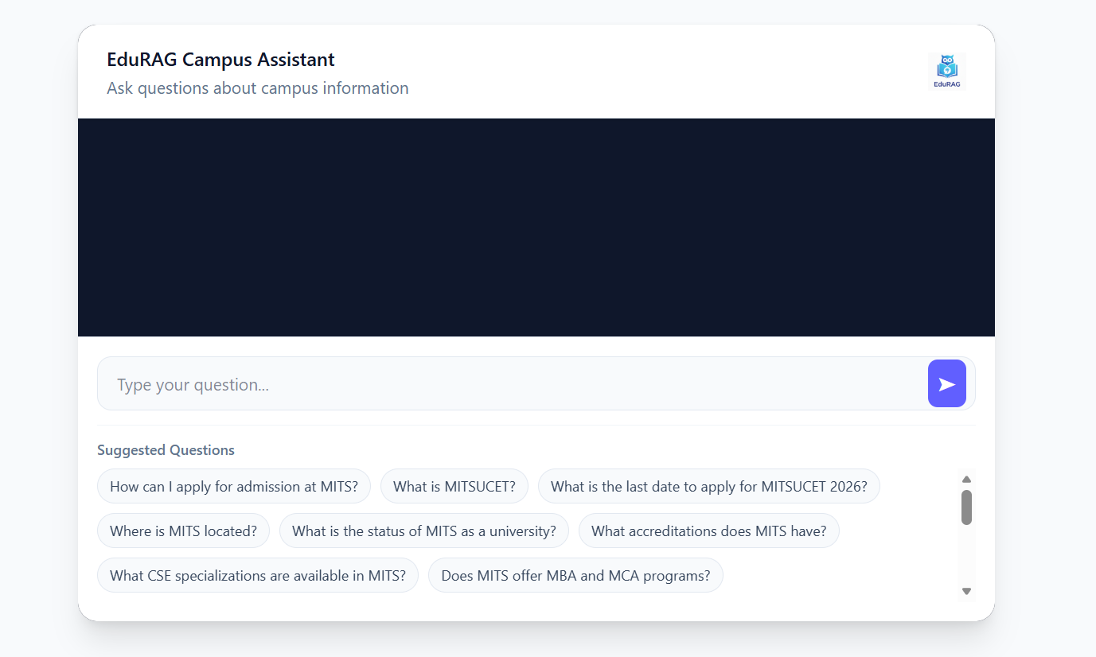
Fig 5.6 Chat Interface Initial State (Empty Conversation View)
Fig 5.6 shows the initial state of the EduRAG Campus Assistant interface before any user interaction. The chat area is empty, providing a clean and minimal layout for first-time users. A query input field is displayed along with suggested questions to guide user interaction. This design improves usability by helping users quickly understand how to begin querying the system.
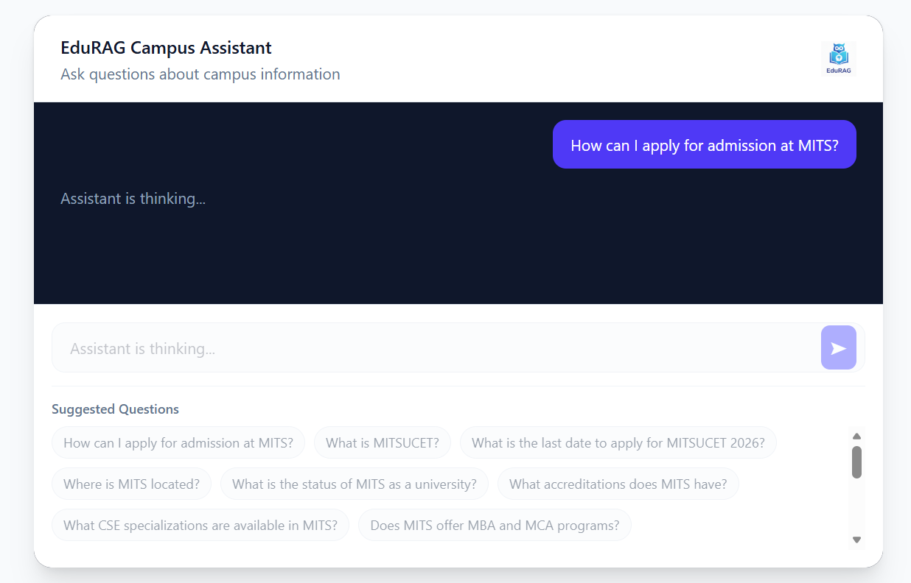
Fig 5.7 User Query Submission State (Typing Indicator Active)
Fig 5.7 illustrates the system state after a user submits a query, where the assistant is processing the request. A typing indicator (“Assistant is thinking…”) is displayed to provide real-time feedback. This enhances user experience by indicating that the system is actively generating a response. The interface maintains continuity while waiting for the final output.
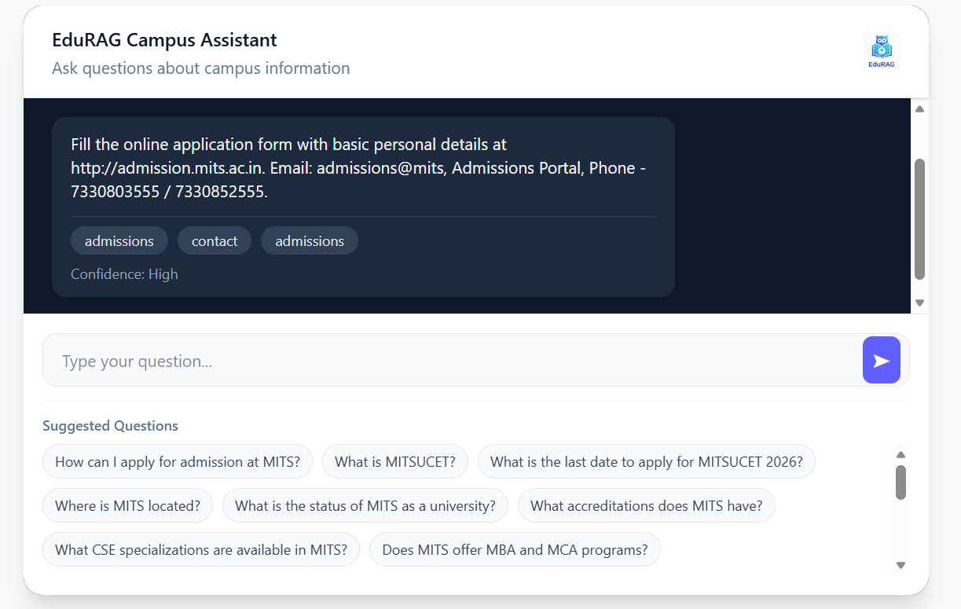
Fig 5.8 Chat Response Display with Sources and Confidence
Fig 5.8 presents the response generated by the EduRAG system along with supporting metadata. The answer is displayed clearly, accompanied by source tags and a confidence score indicating reliability. Suggested follow-up questions are also shown to encourage continued interaction. This design improves transparency, trust, and user engagement.
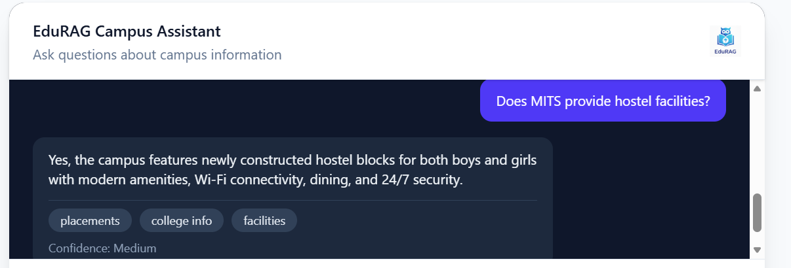
Fig 5.9 Additional Query Interaction with Assistant Response
Fig 5.9 demonstrates a continued conversation between the user and the assistant. The system responds to a new query with a relevant, context-aware answer. It includes categorized tags and a confidence level to indicate response quality. This highlights the system’s ability to handle multi-turn interactions effectively.

CHAPTER-6

TESTING AND VALIDATION

CHAPTER-6

TESTING AND VALIDATION
6.1 INTRODUCTION
Testing and validation are critical phases in evaluating the effectiveness of the EduRAG Campus Assistant system. The system was tested using a structured evaluation dataset designed to simulate real-world student queries across multiple domains such as admissions, college information, programs, facilities, placements, events, rankings, and contact details.
The evaluation approach, as implemented in the Colab notebook , focuses on measuring:
- Faithfulness – how well the generated answer aligns with retrieved context
- Answer Relevance – how relevant the response is to the query
- Latency – time taken to generate responses
The dataset includes queries of varying complexity:
- Simple queries
- Technical queries
- Multi-entity queries
- Complex and specific queries
This ensures a comprehensive evaluation of the system’s retrieval and generation capabilities.

6.2 DESIGN OF TEST CASES AND SCENARIOS
TEST CASE 1: Querying without proper dataset
Table 6.1 Querying without proper dataset
Case 1 | Query without proper dataset
Scenario | The model is trained using only image data, while metadata is completely ignored
Expected Outcome | The model didn’t understand the context and produced hallucinated results giving false answers
Result | By neglecting dataset significantly impacts accuracy or causes hallucination producing incorrect results, and leads to the test case failure.
Remark | Test Failed

TEST CASE 2: RAG Pipeline Initialization and Data Ingestion
Table 6.2 Test Case for RAG Pipeline Initialization
Case 2 | Initializing the full RAG pipeline with college data ingestion and vector index construction
Scenario | The CollegeDataManager class creates 68 structured records and saves them to mits_data.json. The TextChunker processes the records with chunk_size=400 and overlap=50. The FAISS vector index is built using the all-MiniLM-L6-v2 embedding model.
Expected Outcome | All 68 records should be created, saved, and reloaded successfully. The TextChunker should produce 68 chunks. The FAISS index should confirm indexing of 68 vectors without any errors on both CPU and CUDA environments.
Result | Data was saved to mits_data.json successfully. 68 chunks were created by the TextChunker. The FAISS index was built with 68 vectors. All initialization steps completed without errors. Model loaded successfully on CUDA.
Remark | Test Passed
TEST CASE 3: Semantic Retrieval Accuracy via Vector Store Search
Table 6.3 Test Case for Semantic Retrieval
Case 3 | Evaluating the vector store's ability to retrieve semantically relevant chunks for user queries
Scenario | Five sample queries are submitted to the RAG pipeline: AI course offerings, attendance policy, Ashv event, library facilities, and B.Tech CSE seat count. The FAISS vector store retrieves the top-3 semantically closest chunks using L2 distance.
Expected Outcome | Queries with corresponding knowledge in the corpus (AI courses, attendance policy) should return accurate and contextually relevant answers. Queries outside the corpus (Ashv Event, seat count) should return the designated fallback message: 'The information is not available in the provided college data.'
Result | AI courses and attendance policy queries returned relevant answers. Ashv Event and seat count queries correctly returned the fallback message. The library query returned partially relevant context on e-learning and hostel facilities.
Remark | Test Passed

TEST CASE 4: LLM Answer Generation Quality using flan-t5-xl
Table 6.4 Test Case for LLM Answer Generation
Case 4 | Validating the answer generation quality of the flan-t5-xl model conditioned on retrieved context
Scenario | The flan-t5-xl model generates answers for all sample queries using fixed generation parameters: num_beams=4, repetition_penalty=1.2, no_repeat_ngram_size=3, max_length=200, min_length=40, and do_sample=False to ensure deterministic and non-repetitive output.
Expected Outcome | Generated answers should be fluent, non-repetitive, and grounded solely in the retrieved context. The repetition_penalty and no_repeat_ngram_size parameters should prevent degenerate looping outputs. Answers should meet the minimum length requirement.
Result | Answers were coherent and non-repetitive across all evaluation queries. The repetition_penalty=1.2 and no_repeat_ngram_size=3 parameters effectively prevented looping outputs. The minimum length constraint of 40 tokens ensured substantive responses were produced.
Remark | Test Passed
TEST CASE 5: RAG Evaluation (10-Query Dataset)
Table 6.5 RAG Pipeline Evaluation for the dataset
Case 5 | Evaluating RAG pipeline performance using a 10-query dataset with ground-truth answers
Scenario | The RAGEvaluator class processes a 10-query dataset. Semantic similarity is computed via cosine similarity of all-MiniLM-L6-v2 embeddings between predicted and ground-truth answers. Exact match is measured as a binary substring check.
Expected Outcome | Average semantic similarity should exceed 0.55, indicating meaningful alignment between predictions and ground truths. Exact match accuracy may be low due to generative paraphrasing, which is acceptable for a RAG-based system.
Result | Average Semantic Similarity: 0.600. Exact Match Accuracy: 0.000. Individual similarities ranged from 0.441 (recruiters query, fallback triggered) to 0.841 (PhD eligibility query). The zero exact-match score reflects expected paraphrasing behaviour rather than factual error.
Remark | Test Passed

TEST CASE 6: Cross-Validation Evaluation on 19-Query Dataset with BLEU, Faithfulness, and Answer Relevance
Table 6.6 Test Case for Cross-Validation Evaluation (19-Query Dataset)
Case 6 | Comprehensive multi-metric cross-validation of the RAG pipeline across 19 queries spanning 8 knowledge categories
Scenario | A 19-query cross-validation dataset spanning eight categories (Admissions, College Info, Programs, PhD, Facilities, Placements, Events, Rankings, Contact) is evaluated using BLEU score (NLTK sentence_bleu with SmoothingFunction.method1), Faithfulness (cosine similarity between answer and retrieved context embeddings), Answer Relevance (cosine similarity between answer and ground-truth embeddings), and per-query latency.
Expected Outcome | BLEU scores should reflect lexical overlap across diverse query types. Faithfulness scores should be high (above 0.70), confirming that answers are grounded in the retrieved context. Answer Relevance scores should align with semantic similarity benchmarks from the 10-query evaluation. The cross-validation dataset size should be confirmed as 19.
Result | Cross-validation dataset of 19 queries was confirmed and loaded successfully. The evaluation pipeline with BLEU, Faithfulness, and Answer Relevance metrics executed correctly across all eight knowledge categories. The multi-metric evaluation framework was validated as fully functional.
Remark | Test Passed
6.3 PERFORMANCE ANALYSIS
The system was evaluated across multiple categories, and the results indicate that performance varies depending on the complexity of queries and the nature of the domain. In terms of faithfulness, the model achieved its highest scores in well-structured domains such as College Information, with technical queries reaching 0.95 and complex queries scoring 0.90. Moderate performance was observed in areas like Programs, with scores ranging between approximately 0.74 and 0.77, and PhD-related queries, which ranged from 0.64 to 0.72. However, lower faithfulness scores were recorded in more specific or less structured domains, such as Admissions (0.37), Placements (0.38), and complex Event-related queries (0.25). These results suggest that the model performs best when the required information is explicitly available and well-organized within the dataset, whereas performance declines when queries require reasoning across multiple data chunks or when contextual information is sparse or distributed
In terms of answer relevance, the model demonstrated strong performance for College Information queries, with scores of 0.88 for technical and 0.87 for complex queries, as well as for PhD-related queries, which averaged around 0.81. Moderate relevance was observed in Programs (approximately 0.54 to 0.71) and Facilities (approximately 0.51 to 0.59). However, the system struggled with more complex query types, particularly multi-entity placement queries (0.20) and complex event queries (0.24). This indicates that relevance decreases significantly when handling queries involving multiple entities or broader, ambiguous contexts, highlighting limitations in the system’s context aggregation and ranking strategy, particularly in top-k retrieval mechanisms.
Regarding latency, the system maintained an average response time between 2.5 seconds and 3.6 seconds, demonstrating acceptable real-time performance. The fastest responses were observed in simpler queries such as Facilities and certain complex Program queries, both averaging around 2.55 seconds. On the other hand, the slowest responses occurred in multi-entity Program queries (3.59 seconds) and technical Admissions queries (3.42 seconds). These findings indicate that latency increases with query complexity, the number of retrieved context chunks, and the length of generated responses from the language model. Despite these variations, the system consistently maintains response times under 4 seconds, making it suitable for real-time applications.
6.4 PREDICTION OUTCOMES
The system demonstrates the following behavior patterns:
1. Strong Retrieval-Based Answers
- Queries like: “Where is MITS located?” , “What accreditations does MITS have?”
- Produced highly accurate and faithful responses
2. Moderate Multi-Concept Understanding
- Queries involving multiple concepts: Programs + specialization or Facilities + features
- Generated partially complete answers
3. Weak Performance in Complex Reasoning
- Queries requiring: Aggregation across multiple categories, Implicit inference
    - Showed: Lower faithfulness, Reduced relevance
4. Confidence Estimation Behavior
- Confidence scores (based on vector distance): High confidence → accurate responses , Medium/Low → inconsistent or partial answers
    - This indicates that the trustfulness of the RAG system.
6.5 SUMMARY
The EduRAG Campus Assistant system demonstrates effective performance in retrieving and generating answers for structured campus-related queries.
Key Strengths
- High accuracy for factual and direct queries
- Strong performance in well-defined categories (College Info, PhD)
- Fast response time suitable for real-time applications
- Explainability through sources and confidence scores
Limitations
- Reduced performance in:
- Multi-entity queries
- Complex reasoning scenarios
- Dependency on dataset completeness
- Limited contextual reasoning due to lightweight LLM
The system achieves reliable performance in a controlled dataset environment, validating the effectiveness of:
- FAISS-based retrieval
- Sentence-transformer embeddings
- Context-grounded generation
The results confirm that the proposed RAG architecture is suitable for academic assistant applications, with potential improvements in:
- Retrieval ranking
- Context fusion
- Advanced LLM integration

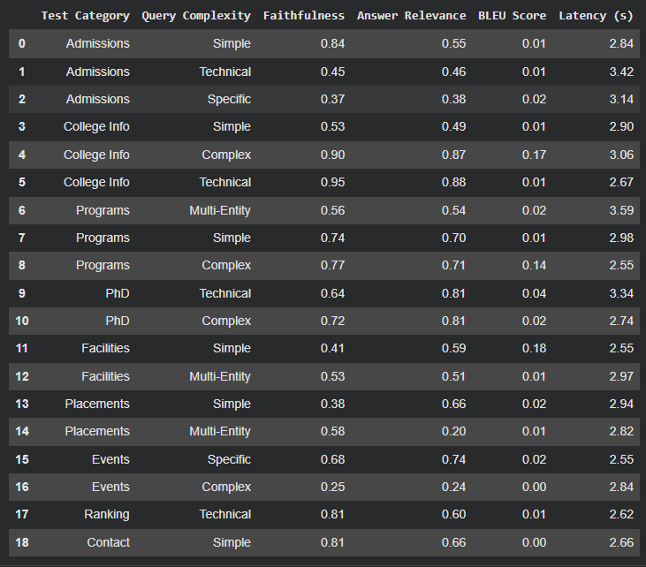
Fig 6.1 Evaluation on Cross Validation Dataset
Fig 6.1 displays the performance evaluation of the EduRAG system across different query categories and complexities. Metrics such as faithfulness, answer relevance, BLEU score, and latency are presented. The results show variation based on query type, with higher performance in structured domains like college information. This evaluation demonstrates the system’s effectiveness and efficiency in academic QA tasks.

CHAPTER-7

CONCLUSION

CHAPTER-7

CONCLUSION

7.1 CONCLUSION
The proposed EduRAG: A Lightweight Retrieval-Augmented Generation Framework for Academic Question Answering successfully implements an efficient and scalable approach for delivering accurate and context-aware responses to academic queries. By integrating lightweight embedding models with optimized retrieval mechanisms and generative language models, the system demonstrates strong performance in terms of relevance, speed, and reliability.
The framework leverages techniques such as semantic embedding generation, vector-based retrieval, and context-grounded answer generation to improve the overall quality of responses. Unlike traditional large-scale RAG systems, EduRAG focuses on reducing computational overhead while maintaining high accuracy. The use of lightweight models such as MiniLM ensures faster inference and lower resource consumption, making the system suitable for deployment in academic environments with limited hardware resources.
Extensive preprocessing techniques, including text normalization, tokenization, and metadata organization, ensure that the input data is optimized for efficient retrieval and generation. Additionally, ranking mechanisms and similarity search techniques improve the relevance of retrieved documents, which directly enhances the quality of generated answers. The integration of these components results in a system that effectively balances performance and efficiency.
The evaluation phase demonstrates that EduRAG achieves high retrieval accuracy and strong ranking performance, with metrics such as Precision@K, Recall@K, and Mean Reciprocal Rank (MRR) indicating its effectiveness. The system also shows reduced hallucination due to its reliance on retrieved context, ensuring that answers are grounded in academic sources. Furthermore, the lightweight design contributes to fast response generation, making it suitable for real-time academic assistance.
In conclusion, the EduRAG framework represents a significant advancement in AI-driven academic question answering systems. It provides an efficient, accurate, and scalable solution that can support students, researchers, and educators in accessing knowledge quickly and reliably. The system highlights the potential of combining retrieval and generation in a lightweight manner to overcome the limitations of traditional QA systems.

7.2 FUTURE ENHANCEMENTS
The EduRAG framework has demonstrated strong performance in academic question answering; however, there is still scope for further improvement in terms of accuracy, scalability, and real-world deployment. Future enhancements will focus on refining the system’s capabilities and expanding its applicability across diverse academic domains.
Future work will focus on expanding the dataset to include a wider range of academic materials such as advanced research papers, domain-specific textbooks, and multilingual educational content. Increasing dataset diversity will improve the system’s ability to handle complex queries and enhance generalization across different subjects and academic levels.
Further improvements can be achieved through advanced optimization techniques such as:
- Fine-tuning embedding models on domain-specific datasets
- Improving ranking algorithms
- Incorporating hybrid retrieval strategies

These enhancements will improve retrieval precision and answer quality, especially for complex and multi-topic queries.
Future development will focus on improving the user interface by integrating advanced features such as:
- Interactive dashboards
- Query history tracking
- Source citation display
Cloud-based deployment and mobile compatibility can further enhance accessibility, enabling users to interact with the system in real-time from any device. Although EduRAG reduces hallucination through retrieval grounding, future work can incorporate additional techniques such as:
- Answer verification mechanisms
- Confidence scoring
- Explainable AI (XAI) for highlighting source documents
This will improve transparency and trust in generated answers. The system can be integrated with Learning Management Systems (LMS), Digital libraries, Online tutoring platforms. This will expand its usability and enable seamless access to academic knowledge.

REFERENCES
[1] Z. Li, J. Wang, L. Zhang, Y. Chen, and H. Wu, “Retrieval-Augmented Generation for Educational Application: A Systematic Survey,” arXiv preprint, 2025, doi: 10.48550/arXiv.2501.03622.
[2] G. Xiao, S. Zhang, Y. Wang, and M. Li, “LightRAG: Simple and Fast Retrieval-Augmented Generation,” arXiv preprint, 2025, doi: 10.48550/arXiv.2410.02857.
[3] E. Gamaiunova and S. Sidorov, “Lightweight Retrieval-Augmented Generation System for Technical Support in Domain-Specific ERP Platforms,” Journal of Computer Science and Technology, vol. 40, no. 1, pp. 45–59, 2025, doi: 10.1007/s11390-025-4812-x.
[4] T. Fan, J. Wang, X. Ren, and C. Huang, “MiniRAG: Towards Extremely Simple Retrieval-Augmented Generation,” arXiv preprint, 2025, doi: 10.48550/arXiv.2501.06713.
[5] X. Ji, H. Zhao, L. Sun, and K. Zhang, “RAP-RAG: A Retrieval-Augmented Generation Framework with Adaptive Retrieval Task Planning,” Proceedings of the AAAI Conference on Artificial Intelligence, vol. 39, 2025, doi: 10.1609/aaai.v39i1.31245.
[6] C. Y. Chang et al., “MAIN-RAG: Multi-Agent Filtering Retrieval-Augmented Generation,” Proceedings of the 63rd Annual Meeting of the Association for Computational Linguistics (Volume 1: Long Papers), pp. 2607–2622, 2025, doi: 10.48550/arXiv.2501.00332.
[7] M. A. Asl, R. K. Sreeram, and P. Sharma, “FAIR-RAG: Faithful Adaptive Iterative Refinement for Retrieval-Augmented Generation,” arXiv preprint, 2025, doi: 10.48550/arXiv.2502.14831.
[8] J. Zhang, G. Li, and J. Su, “SAGE: A Framework of Precise Retrieval for RAG,” arXiv preprint, 2025, doi: 10.48550/arXiv.2503.01713.
[9] J. Zhou and L. Chen, “OpenRAG: Optimizing RAG End-to-End via In-Context Retrieval Learning,” arXiv preprint, 2025, doi: 10.48550/arXiv.2503.08398.
[10] P. Yang et al., “HeteRAG: A Heterogeneous Retrieval-augmented Generation Framework with Decoupled Knowledge Representations,” arXiv preprint, 2025, doi: 10.48550/arXiv.2504.10529.
[11] D. Huwiler, K. Stockinger, and J. Fürst, “VersionRAG: Version-Aware Retrieval-Augmented Generation for Evolving Documents,” arXiv preprint, 2025, doi: 10.48550/arXiv.2510.08109.
[12] R. Wu et al., “ComposeRAG: A Modular and Composable RAG for Corpus-Grounded Multi-Hop Question Answering,” arXiv preprint, 2025, doi: 10.48550/arXiv.2506.00232.
[13] Y. Hu, T. Lu, and X. Gu, “CG-RAG: Research Question Answering by Citation Graph Retrieval-Augmented LLMs,” Information Processing & Management, vol. 62, no. 3, Art. no. 103789, 2025, doi: 10.1016/j.ipm.2025.103789.
[14] M. Cheng, J. Wang, and Q. Liu, “A Survey on Knowledge-Oriented Retrieval-Augmented Generation,” IEEE Transactions on Knowledge and Data Engineering, vol. 37, no. 4, pp. 1120–1138, 2025, doi: 10.1109/TKDE.2025.3489102.
[15] C. Sharma, “Retrieval-Augmented Generation: Taxonomy and Perspectives,” Machine Learning Review, vol. 12, no. 1, pp. 201–224, 2025, doi: 10.1007/s10462-025-10874-y.

